|  |
| --- |
|  |
| Java Programming Language |
|  |

|  |
| --- |
| C:\Users\philong\Downloads\java-logo.png |

* **classes and objects**

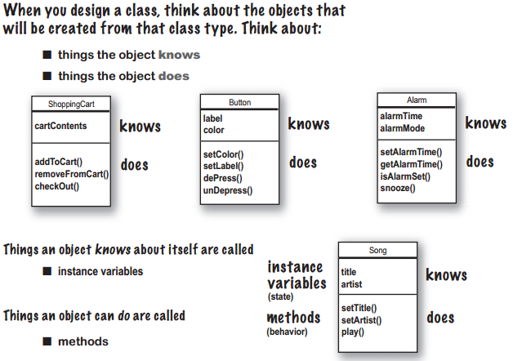

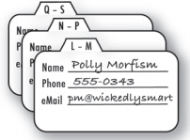 

**Think of instance as another way of saying object.**

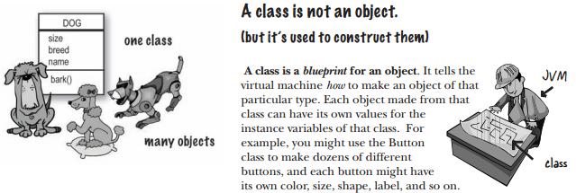

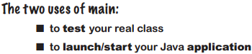

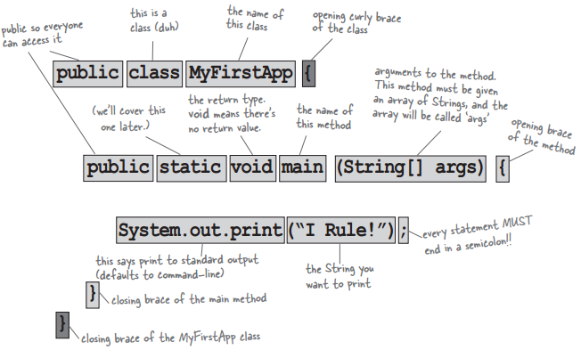

**Back away from that keyword!**

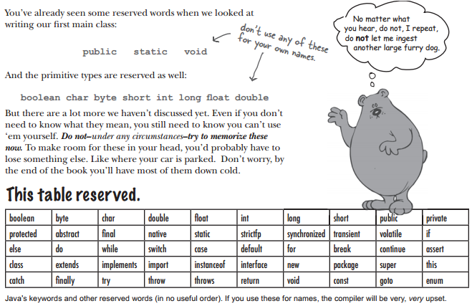

* **primitives and references**

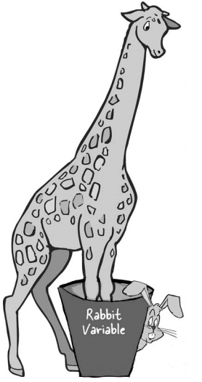



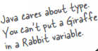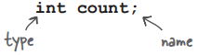

When you think of Java variables, think of cups.

**A variable is just a cup. A container. It holds something.**

It has a size, and a type.

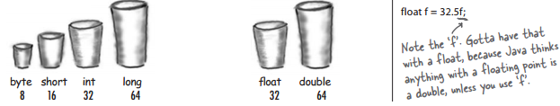

**You really don’t want to spill that...Be sure the value can fit into the variable.**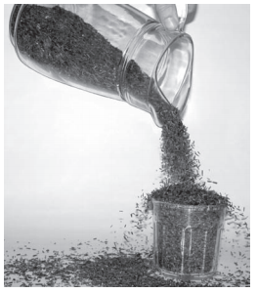

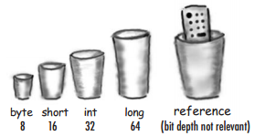 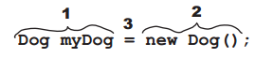

* **Loop, branching**

**-Regular (non-enhanced) for, enhanced for** , **while, do .. while**

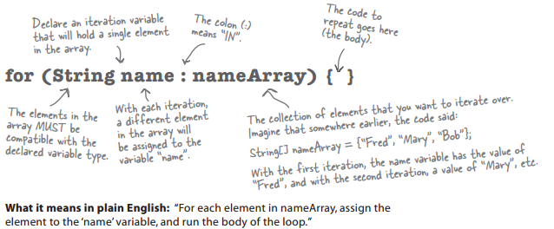

**-if, if else, else if, switch case**

Switch : byte, short, char, int, Enum, String, Character, Integer, Byte, Short

The key to a loop, branching is the *conditional test*.

**-Super Powerful Boolean Expressions**

Short Circuit Operators ( && , || )

The operators we’ve looked at so far, && and ||, are known as short circuit operators. In the case of &&, the expression will be true only if both sides of the && are true. So if the JVM sees that the left side of a && expression is false, it stops right there! Doesn’t even bother to look at the right side.

Similarly, with ||, the expression will be true if either side is true, so if the JVM sees that the left side is true, it declares the entire statement to be true and doesn’t bother to check the right side.

Non Short Circuit Operators ( & , | )

When used in boolean expressions, the & and | operators act like their && and || counterparts, except that they force the JVM to **always check both sides of the expression**. Typically, & and | are used in another context, for manipulating bits.

Simple boolean tests

!= == > >= < <=

**Bit Manipulation**

& | ^ ! >> >>> << <<<

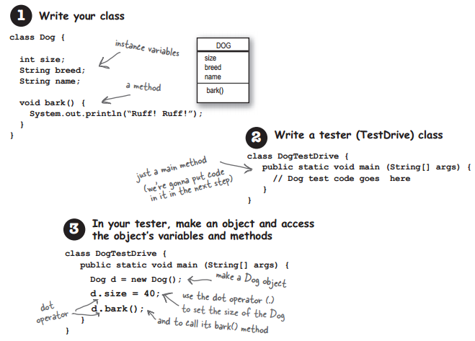



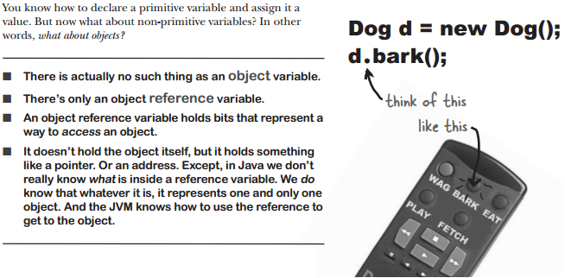

**myDog.bark();**  means, “use the object referenced by the variable myDog to invoke the bark() method.

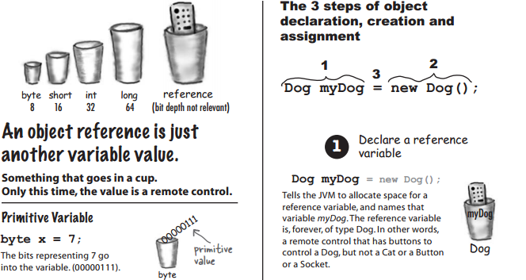

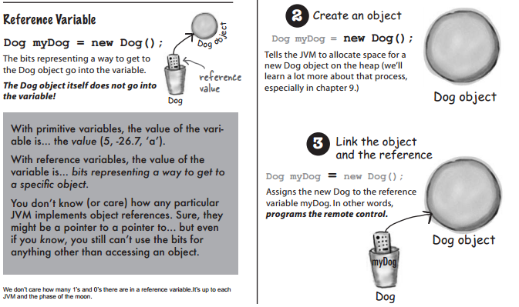

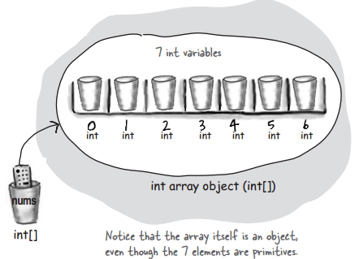

int[] nums;

nums = new int[7];

nums[0] = 6;

nums[1] = 19;

nums[2] = 44;

nums[3] = 42;

nums[4] = 10;

nums[5] = 20;

nums[6] = 1;

**Arrays are objects too**

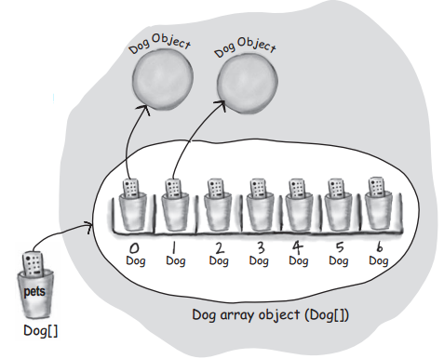

Dog[] pets;

pets = new Dog[7];

pets[0] = new Dog();

pets[1] = new Dog();

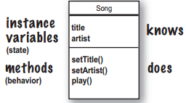

**You can send more than one thing to a method**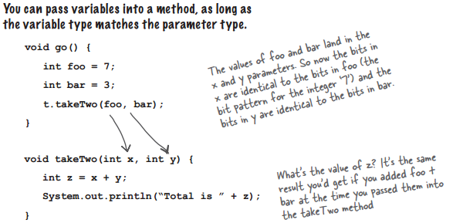

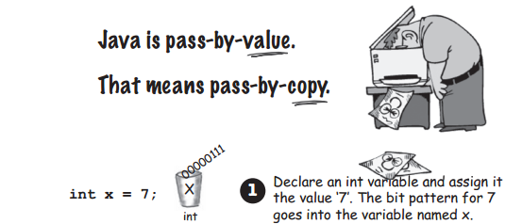

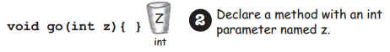

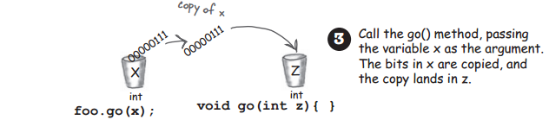

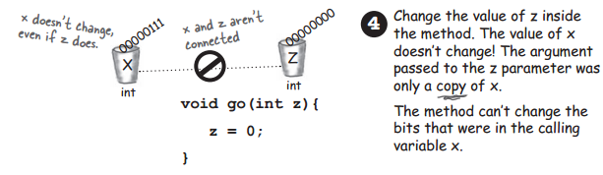

* Enum Types

An enum type is a special data type that enables for a variable to be a set of predefined constants. The variable must be equal to one of the values that have been predefined for it. Common examples include compass directions (values of NORTH, SOUTH, EAST, and WEST) and the days of the week.

The basic idea behind Java’s enum types is simple: they are classes that export one instance for each enumeration constant via a public static final field. Enum types are effectively final, by virtue of having no accessible constructors. Because clients can neither create instances of an enum type nor extend it, there can be no instances but the declared enum constants.

Using “if” and “switch” with Enums

Using the enum we just created, we can perform branches in our code using either the if or switch statement. Also notice that we can compare enum instances using either ==or the .equals()method. Usually ==is considered better style.

**public** **class** HfjEnum {

**enum** Names {

***JERRY***("lead guitar") {

**public** String sings() {

**return** "plaintively";

}

},

***BOBBY***("rhythm guitar") {

**public** String sings() {

**return** "hoarsely";

}

},

***PHIL***("bass");

**private** String instrument;

Names(String instrument) {

**this**.instrument = instrument;

}

**public** String getInstrument() {

**return** **this**.instrument;

}

**public** String sings() {

**return** "occasionally";

}

}// enum Names

**public** **static** **void** main(String[] args) {

**for** (Names n : Names.*values*()) {

System.***out***.print(n);

System.***out***.print(", instrument: " + n.getInstrument());

System.***out***.println(", sings: " + n.sings());

}

}

}

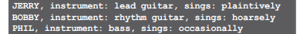

public enum Members{ JERRY, BOBBY, PHIL };

public Members selectedBandMember;

// later in the code

if (selectedBandMember == Members.JERRY) {

// do JERRY related stuff

}

Members n = Members.BOBBY;

if(n.equals(Members.JERRY))

System.out.println(“Jerrrry!”);

if(n == Members.BOBBY)

System.out.println(“Rat Dog”);

Members ifName = Members.PHIL;

switch(ifName) {

case JERRY: System.out.print(“make it sing “);

case PHIL: System.out.print(“go deep “);

case BOBBY: System.out.println(“Cassidy! ”);

}

* **Encapsulation**

Mark instance variables private.

Mark getters and setters public.

**Instance variables always get a default value.** If you don’t explicitly assign a value to an instance

variable, or you don’t call a setter method, the instance variable still has a value!

**integers 0**

**floating points 0.0**

**booleans false**

**references null**

**Local variables do NOT get a default value!** The compiler complains if you try to use a local variable before the variable is initialized.

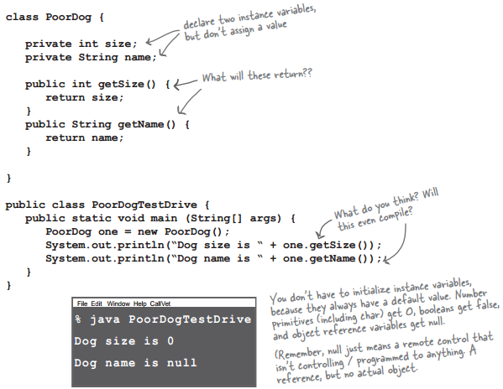



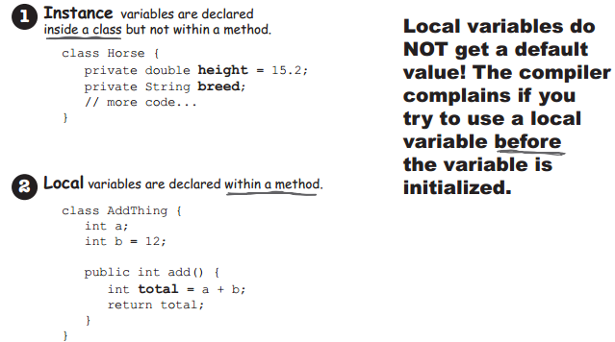

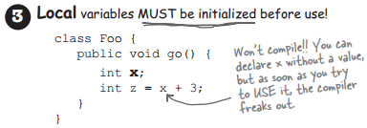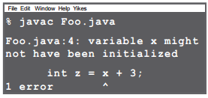



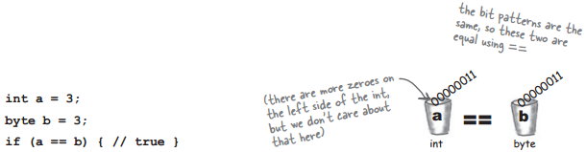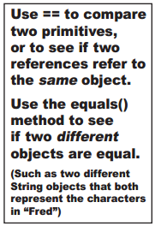





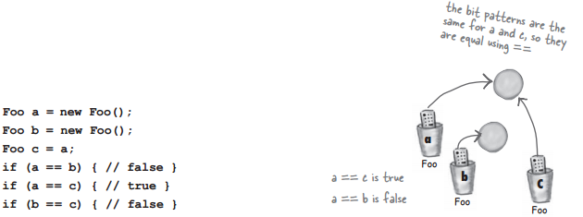

**Comparing variables (primitives or references)**

Use == to compare two primitives, or to see if two references refer to the same object.

Use the equals() method to see if two different objects are equal.

(Such as two different String objects that both represent the characters in “Fred”)

**Getting user input using**

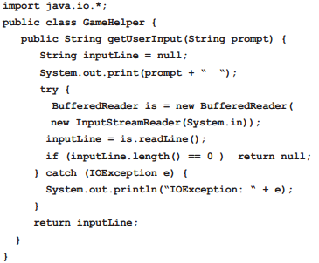



java.util

Class Scanner

For example, this code allows a user to read a number from System.in:

Scanner sc = new Scanner(System.in);

int i = sc.nextInt();







Casting primitives

int x = (int) y;

**Package**

To make types easier to find and use, to avoid naming conflicts, and to control access, programmers bundle groups of related types into packages.

  A *package* is a grouping of related types providing access protection and name space management. Note that *types* refers to classes, interfaces, enumerations, and annotation types. Enumerations and annotation types are special kinds of classes and interfaces, respectively, so *types* are often referred to in this lesson simply as *classes and interfaces*.

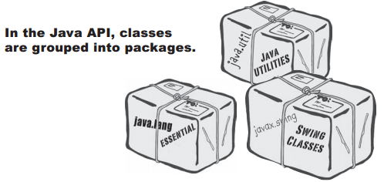

To use a class in the API, you have to know which package the class is in.

<http://docs.oracle.com/javase/7/docs/api/>

* **inheritance and polymorphism**

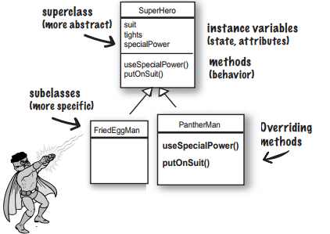

When one class inherits from another,**the subclass inherits from the superclass**.

In Java, we say that the **subclass extends the superclass.**

**Instance variables are not overridden** because they don’t need to be.

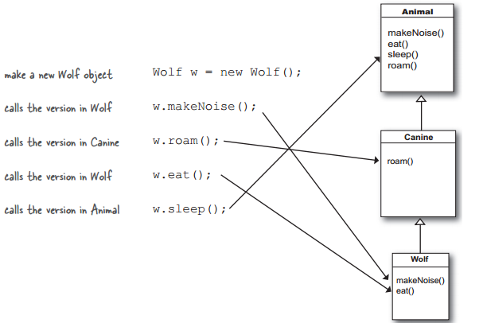

Which method is called?

**the lowest one wins!**

**Using IS-A**

The IS-A test works *anywhere* in the inheritance tree. If your inheritance tree is well-designed, the IS-A test should make sense when you ask any subclass if it IS-A *any* of its supertypes.

**If class B extends class A, class B IS-A class A.This is true anywhere in the inheritance tree. If class C extends class B, class C passes the IS-A test for both B and A.**

Canine extends Animal

Wolf extends Canine

Wolf extends Animal

Canine IS-A Animal

Wolf IS-A Canine

Wolf IS-A Animal

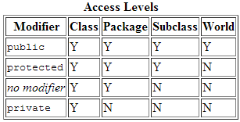Keep in mind that the inheritance IS-A relationship works in only one direction!

**Access levels control who sees what**

Public members **are** inherited

Private members are **not** inherited

**So what does all this inheritance really buy you?**

1. You avoid duplicate code.
2. You define a common protocol for a group of classes.

Inheritance lets you guarantee that all classes grouped under a certain super type have all the methods that the super type has.

*In other words, you define a common protocol for a set of classes related through inheritance.*

The important point is that the reference type AND the object type are the same.

In this example, both are Dog.

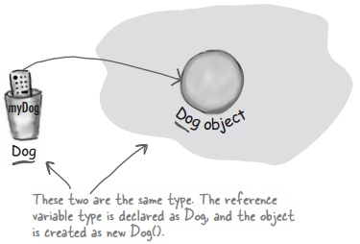

But with polymorphism, the reference and the object can be different.

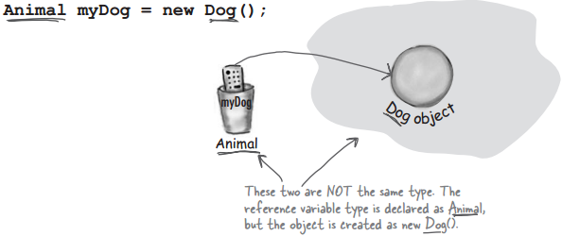

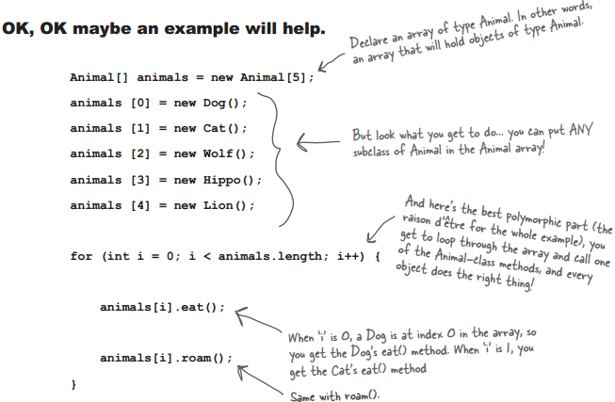

**You can have polymorphic arguments and return types.**

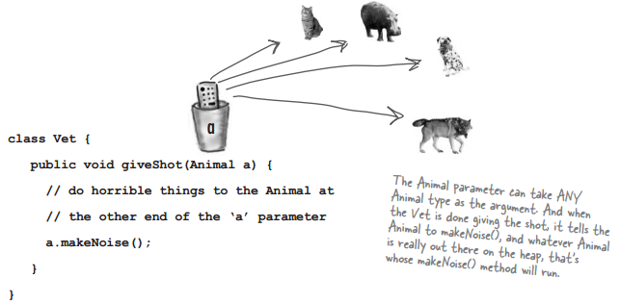

There are three things that can prevent a class from being subclassed. The first is **access control**. Even though a class can’t be marked private, a class canbe non-public. A non-public class can be subclassed only by classes in the same package as the class. Classes in a different package won’t be able to subclass the non-public class.The second thing that stops a class from being subclassed is the keyword **modifier final**. A final class means that it’s the end of the inheritance line. Nobody, ever, can extend a final class.The third issue is that if a class has only **private constructors**, it can’t be subclassed.



The arguments and return types of your overriding method must look to the outside world exactly like the overridden method in the superclass.

1. **Arguments must be the same, and return types must be compatible.**
2. **The method can’t be less accessible.**  (public > protected > default > private)

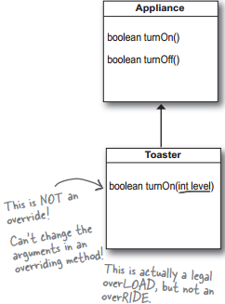 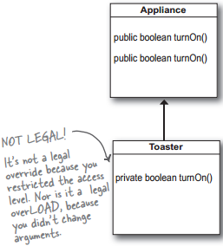



An overloaded method is just a different method that happens to have the same method name. It has nothing to do with inheritance and polymorphism. An overloaded method is NOT the same as an overridden method.

1. **The return types can be different.**
2. **You can’t change ONLY the return type.**
3. **You can vary the access levels in any direction.**

Legal examples of method overloading:

public class Overloads {

String uniqueID;

public int addNums(int a, int b){

return a + b;

}

public double addNums(double a, double b){

return a + b;

}

public void setUniqueID(String theID){

// lots of validation code, and then:

uniqueID = theID;

}

public void setUniqueID(int ssNumber){

String numString = “” + ssNumber;

setUniqueID(numString);

}

}

* **interfaces and abstract classes**

**Did we forget about something when we designed this?**

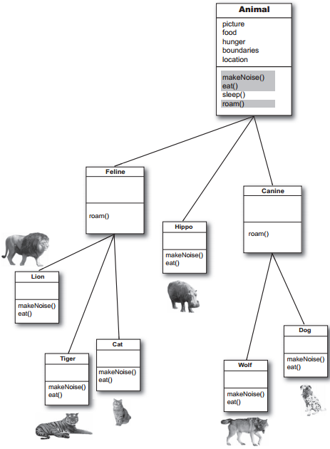

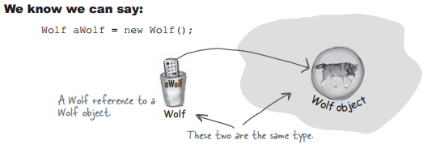

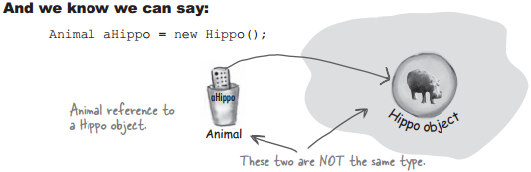

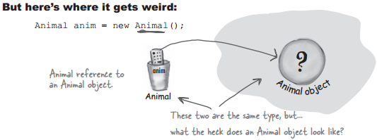

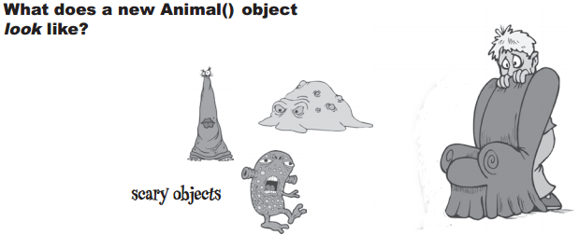

What are the instance variable values?

**Some classes just should not be instantiated!**

Making a class abstract is easy—put the keyword **abstract** before the class declaration:

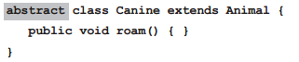

**Abstract vs. Concrete**

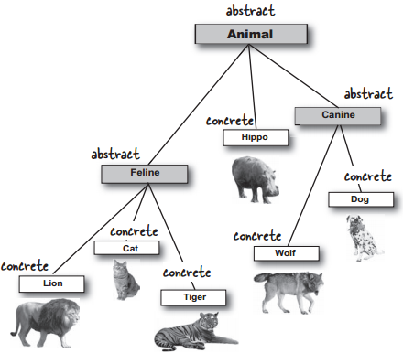



**An abstract method has no body!**

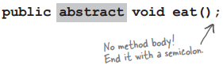

**If you declare an abstract method, you MUST mark the class abstract as well. You can’t have an abstract method in a non-abstract class.**

If you put even a single abstract method in a class, you have to make the class abstract. But you can mix both abstract and nonabstract methods in the abstract class.



Implementing an abstract method is just like overriding a method.

**Every class in Java extends class Object.**

So you were making subclasses of class Object from the very beginning and you didn’t even

know it. Every class you write extends Object,without your ever having to say it. But you can

think of it as though a class you write looks like this:

public class Dog **extends Object**{ }

But wait a minute, Dog already extends something, Canine. That’s OK. The compiler will make Canine extend Object instead. Except Canine extends Animal. No problem, then the compiler will just make Animal extend Object.

**Any class that doesn’t explicitly extend another class, implicitly extends Object.**



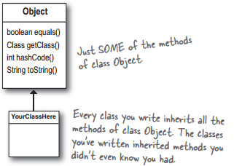

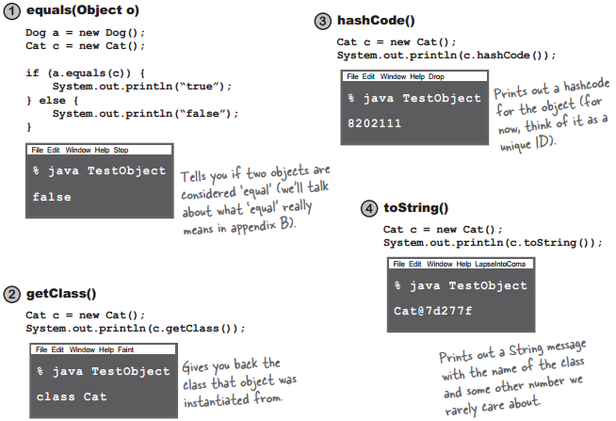

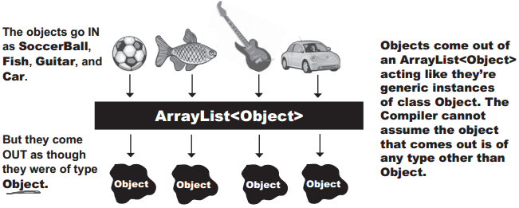

**The compiler decides whether you can call a method based on the reference type, not the**

**actual object type.**



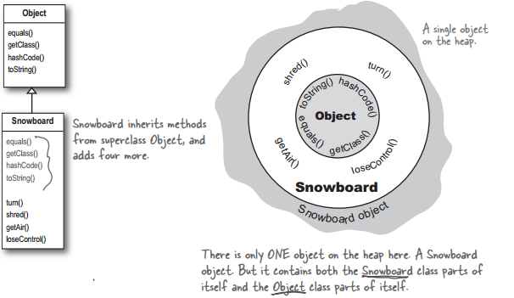

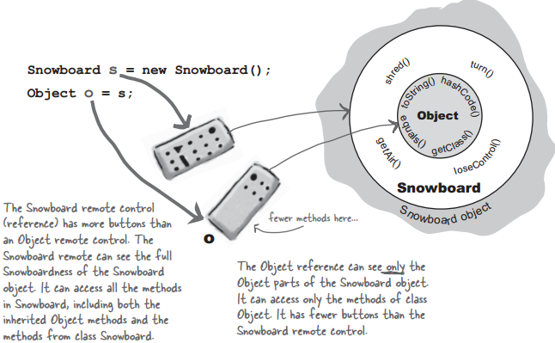

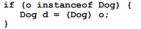

**Let’s explore some design options for reusing some of our existing classes in a PetShop program.**

**So what we REALLY need is:**

 A way to have pet behavior in just the pet classes

 A way to guarantee that all pet classes have all of the same methods defined (same name, same arguments, same return types, no missing methods, etc.), without having to cross your

fingers and hope all the programmers get it right.

 A way to take advantage of polymorphism so that all pets can have their pet methods called, without having to use arguments, return types, and arrays for each and every pet class.

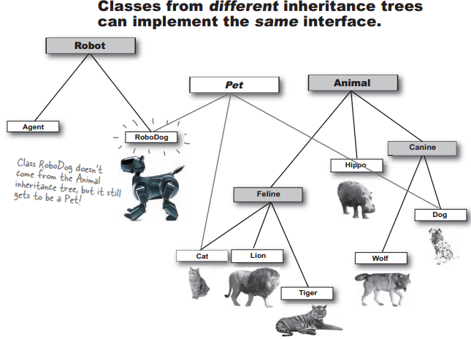



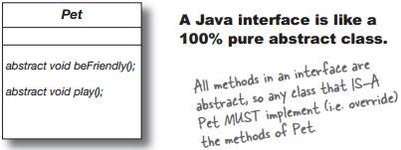

A Java interface solves your **multiple inheritance** problem by giving you much of the polymorphic benefits of multiple inheritance. Make all the methods abstract! That way, the subclass must implement the methods (remember, abstract methods must be implemented by the first concrete subclass).

**Abstract class must extends Abstract method must overriding**

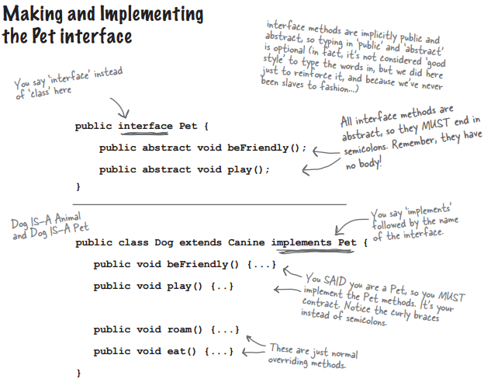

With an interface, a class doesn’t have to come from just one inheritance tree. A class can extend one class, and implement an interface. But another class might implement the same interface, yet come from a completely different inheritance tree!

But when you use an interface as a polymorphic type (like an array of Pets), the objects can be

from anywhere in the inheritance tree. The only requirement is that the objects are from a class that implements the interface. Allowing classes in different inheritance trees to implement a common interface is crucial in the Java API.

**Better still, a class can implement multiple interfaces!**

*public class Dog extends Animal implements Pet, Saveable, Paintable { ... }*

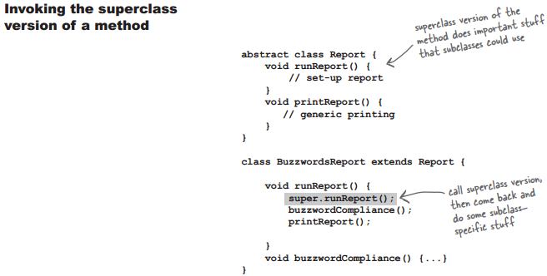

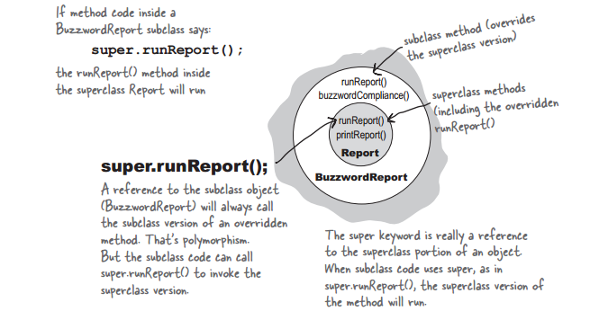

* Your class can implement multiple interfaces.
* A class that implements an interface must implement all the methods of the interface, since all interface methods are implicitly public and abstract.
* To invoke the superclass version of a method from a subclass that’s overridden the method, use the super keyword. Example: super.runReport();
* **How do you know whether to make a class, a subclass, an abstract class, or an interface?**
* Make a class that doesn’t extend anything (other than Object) when your new class doesn’t pass the IS-A test for any other type.
* Make a subclass (in other words, extend a class) only when you need to make a more specific version of a class and need to override or add new behaviors.
* Use an abstract class when you want to define a template for a group of subclasses, and you have at least some implementation code that all subclasses could use. Make the class abstract when you want to guarantee that nobody can make objects of that type.
* Use an interface when you want to define a role that other classes can play, regardless of where those classes are in the inheritance tree.
* **interfaces and abstract classes**

An abstract class with no non abstract methods is similar to an interface in terms of its utility.

However, note the following.

• A class can implement any number of interfaces but can subclass at most one abstract class.

• An abstract class can have non abstract methods, which are usually instances of the *TEMPLATE METHOD* pattern. All the methods of an interface are abstract, whether or not this declaration is explicit. **(*)**

• An abstract class can declare instance variables that its subclasses inherit. An interface cannot declare instance variables, although it can establish *static final* fields.

• An abstract class can define constructors; an interface cannot.

• An *abstract class's* visibility can be *public, protected, private, or none (package);* an *interface's* visibility must be *public or none (package).*

• An *abstract class* can have *methods* whose visibility is *protected, private, or none (package);* every method in an *interface* must be *public*.

• An abstract class inherits from *Object*, including such methods as *clone*()and *equals*().

* **constructors and garbage collection**



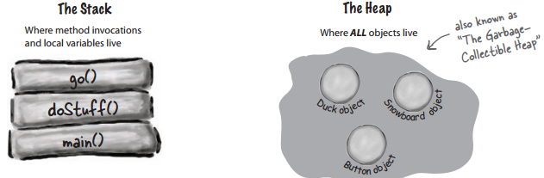

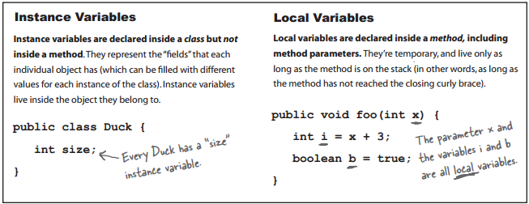

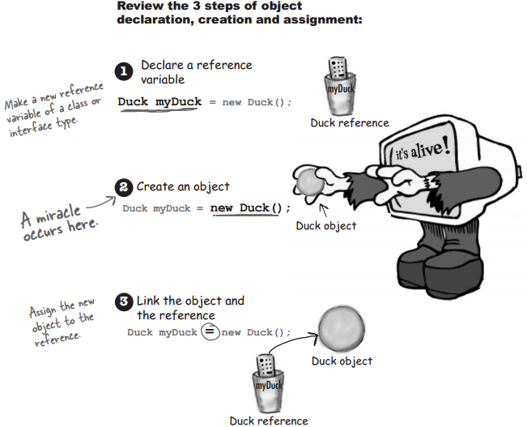

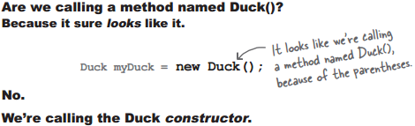 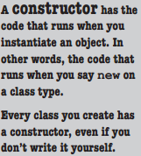

A **constructor** has the code that runs when you instantiate an object. In other words, the code that

runs when you say new on a class type. Every class you create has a constructor, even if you

don’t write it yourself.

**If you don’t provide a constructor**

The compiler puts one in that looks like:

public ClassName() {

super();

}

The call to **super()** must be the first statement in each constructor!*

Use **this()** to call a constructor from another overloaded constructor in the same class.

The call to this() can be used only in a constructor, and must be the first statement in a constructor.

A constructor can have a call to super() OR this(), but never both!

public class Foo {

private int x;

public Foo() {

this(1);

}

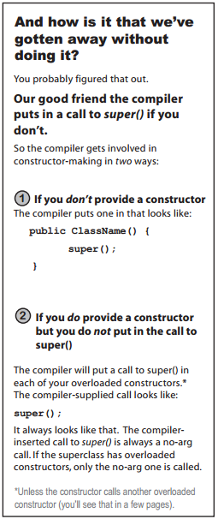 public Foo(int x) {

this.x = x;

}

}

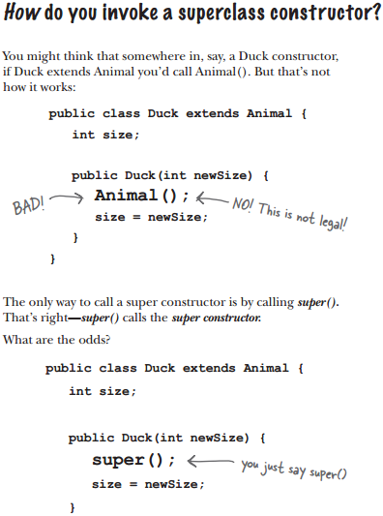

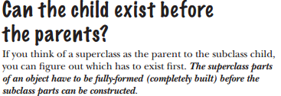 

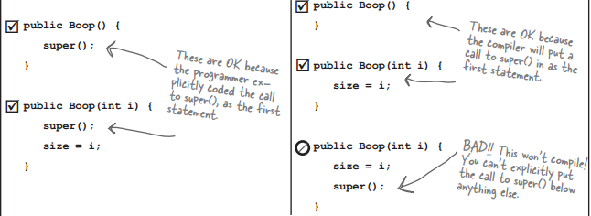



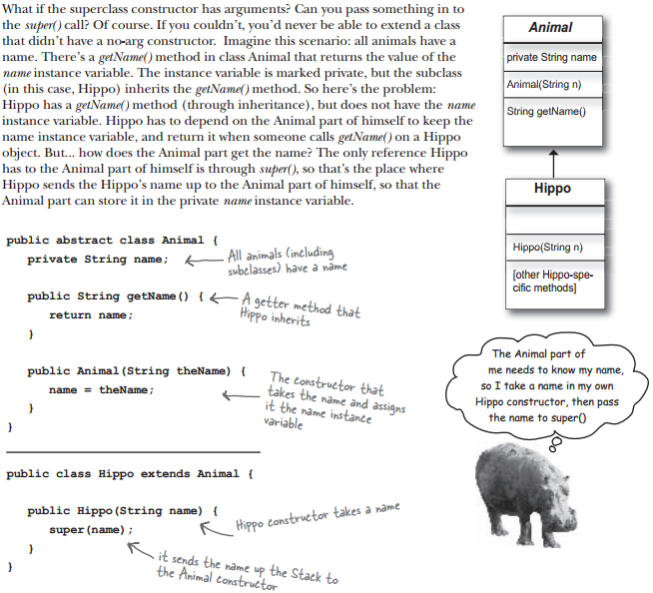

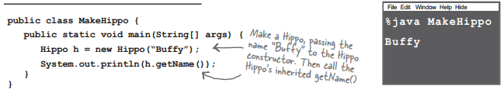

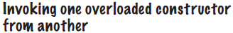

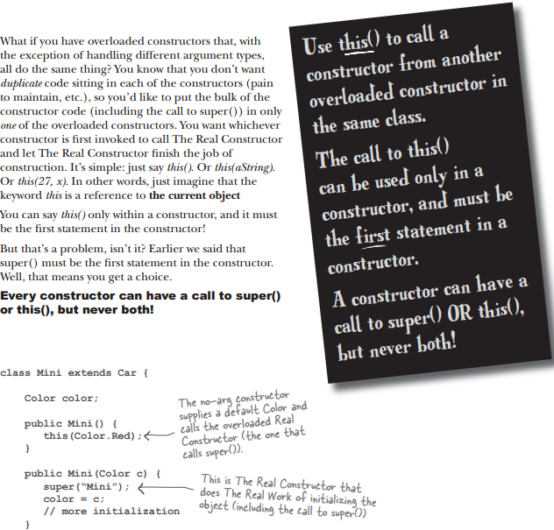

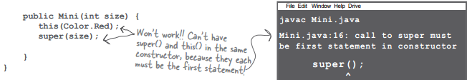

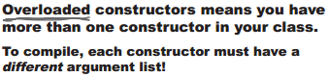

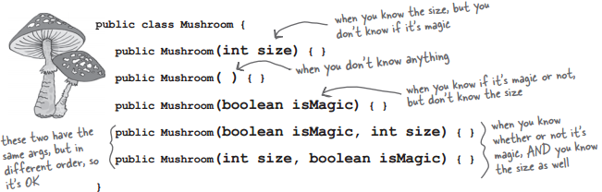

* If you don’t put a constructor in your class, the compiler will put in a default constructor.
* The default constructor is always a no-arg constructor.
* If you put a constructor—any constructor—in your class, the compiler will not build the default constructor.
* If you want a no-arg constructor, and you’ve already put in a constructor with arguments, you’ll have to build the no-arg constructor yourself.
* Always provide a no-arg constructor if you can, to make it easy for programmers to make a working object. Supply default values.

**superclasses and inheritance and how that all fits in with constructors.**

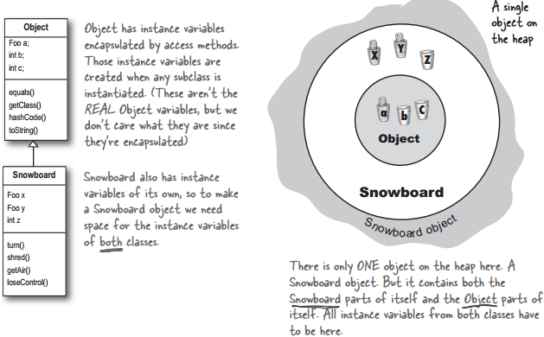

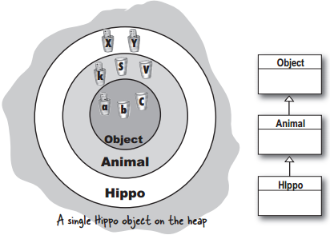**The role of superclass constructors in an object’s life.**

**All the constructors in an object’s inheritance tree must run when you make a new object.**

A new Hippo object also IS-A Animal

and IS-A Object. If you want to make a

Hippo, you must also make the Animal

and Objectparts of the Hippo.

This all happens in a process called

Constructor Chaining.

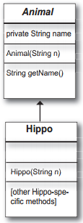public abstract class Animal {

private String name;

public String getName() {

return name;

}

public Animal(String theName) {

name = theName;

}

}

public class Hippo extends Animal {

public Hippo(String name) {

super(name);

}

}

public class MakeHippo {

public static void main(String[] args) {

Hippo h = new Hippo(“Buffy”);

System.out.println(h.getName());

}

}

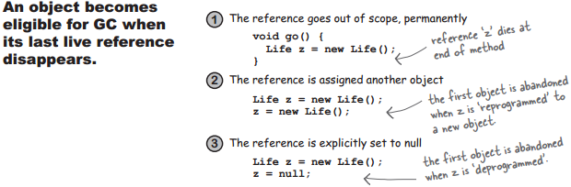

* **numbers and statics**

MATH methods: as close as you’ll ever get to a global method.

Methods in the Math class don’t use any instance variable values. And because the methods are ‘static’, you don’t need to have an instance of Math. All you need is the Math class.

These methods never use instance variable values. In fact the Math class doesn’t have any instance variables.

int x = Math.round(42.2);

int y = Math.min(56,12);

int z = Math.abs(-343);

**Math methods**

**Math.random()**

Returns a double between 0.0 through (but not including) 1.0.

double r1 = Math.random();

int r2 = (int) (Math.random() * 5);

**Math.abs()**

int x = Math.abs(-240); // returns 240

double d = Math.abs(240.45); // returns 240.45

**Math.round()**

int x = Math.round(-24.8f); // returns -25

int y = Math.round(24.45f); // returns 24

**Math.min()**

intx = Math.min(24,240); // returns 24

double y = Math.min(90876.5, 90876.49); // returns 90876.49

**Math.max()**

intx = Math.max(24,240); // returns 240

double y = Math.max(90876.5, 90876.49); // returns 90876.5

The keyword **static** lets a method run **without any instance of the class**. A static method means

“behavior not dependent on an instance variable, so no instance/object is required. Just the class.”

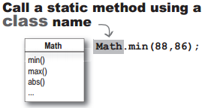 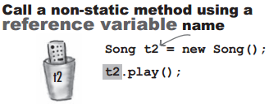

**Static methods can’t use non-static (instance) variables!**

If you try to use an instance variable from inside a static method, the compiler thinks, “I don’t know which object’s instance variable you’re talking about!” If you have ten Duck objects on the heap, a static method doesn’t know about any of them.

**Static variable**:

value is the same for ALL instances of the class

**Static variables are shared.**

**All instances of the same class share a single copy of the static variables.**

instance variables: 1 per **instance**

static variables: 1 per **class**

**Initializing a static variable**

**All static variables in a class are initialized before any object of that class can be created.**

And there are two guarantees about static initialization:

Static variables in a class are initialized before any object of that class can be created.

Static variables in a class are initialized before any static method of the class runs.

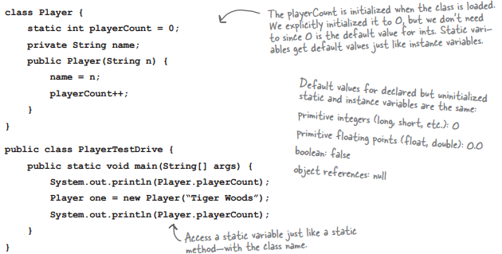





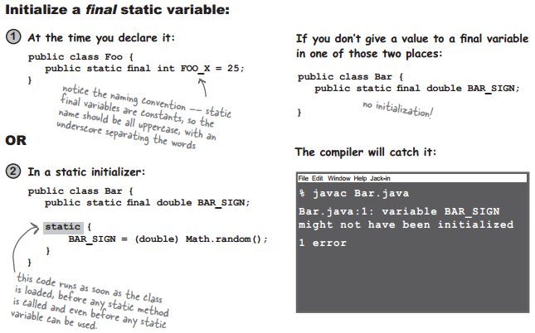

A final **variable** means you can’t **change** its value.

A final **method** means you can’t **override** the method.

A final **class** means you can’t **extend** the class (i.e. you can’t make a subclass).

**non-static final variables**

class Foof {

final int size = 3;

//now you can’t change size

final int whuffie;

Foof() {

whuffie = 42;

//now you can’t change whuffie

}

void doStuff(final int x) {

// you can’t change x

}

void doMore() {

final int z = 7;

// you can’t change z

}

}

**final method**

class Poof {

final void calcWhuffie() {

// important things

// that must never be overridden

}

}

**final class**

final class MyMostPerfectClass {

// cannot be extended

}

**Wrapping a primitive**

When you need to treat a primitive like an object, wrap it. If you’re using any version of Java before 5.0, you’ll do this when you need to store a primitive value inside a collection like ArrayList or HashMap.

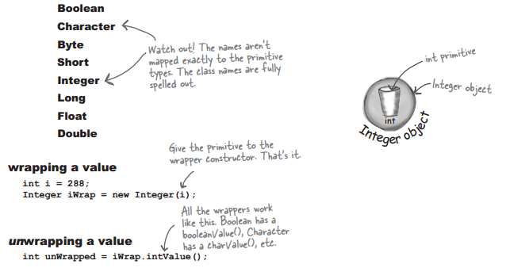

Converting a String to a primitive value is easy:

String s = “2”; // String s = “two”; -- error

int x = Integer.parseInt(s);

double d = Double.parseDouble(“420.24”);

boolean b = new Boolean(“true”).booleanValue();

And now in reverse... turning a primitive number into a String

double d = 42.5;

String doubleString = “” + d;

double d = 42.5;

String doubleString = Double.toString(d);

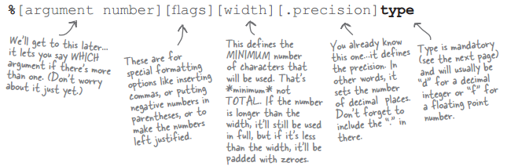

int one = 20456654;

double two = 100567890.248907;

String s = String.format(“The rank is %,d out of %,.2f”, one, two);

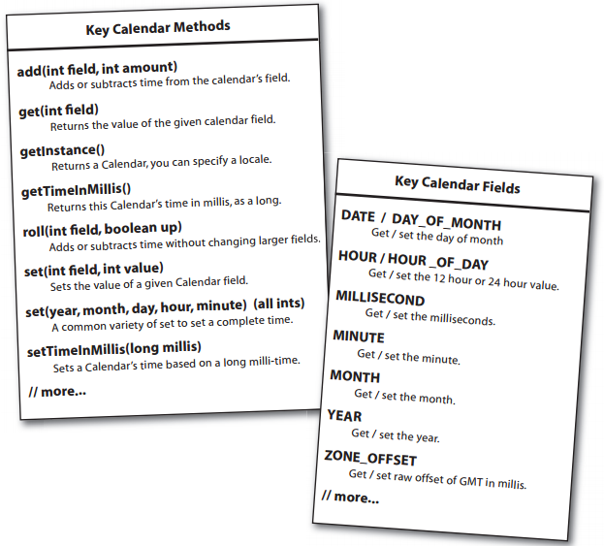

First, full moons happen every 29.52 days or so. Second, there was a full moon on Jan. 7th, 2004. (plus more full moon dates).

import java.util.*;

import static java.lang.System.out;

class FullMoons {

static int DAY_IM = 1000 * 60 * 60 * 24;

public static void main(String [] args) {

Calendar c = Calendar.getInstance();

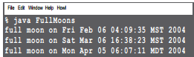c.set(2004,0,7,15,40);

long day1 = c.getTimeInMillis();

for (int x = 0; x < 60; x++) {

day1 += (DAY_IM * 29.52)

c.setTimeInMillis(day1);

out.println(String.format(“full moon on %tc”, c));

}

}

}

* **Exception handling**

The compiler needs to know that YOU know you’re calling a risky method.

**An exception is an object...of type Exception.**

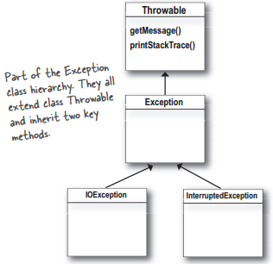 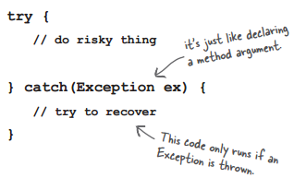

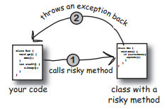

**One method will catch what another method throws. An exception is always thrown back to the**

**caller. The method that throws has to declare that it might throw the exception.**

The compiler does NOT pay attention to exceptions that are of type RuntimeException. A RuntimeException does not have to be declared or wrapped in a try/catch (although you’re free to do either or both of those things)

class MyEx extends Exception { }

public class ExTestDrive {

public static void main(String []

args) {

String test = args[0];

try {

System.out.print(“t”);

doRisky(test);

System.out.print(“o”);

} catch ( MyEx e) {

System.out.print(“a”);

}

finally {

System.out.print(“w”);

}

System.out.println(“s”);

}

static void doRisky(String t)

throws MyEx {

System.out.print(“h”);

if (“yes”.equals(t)) {

throw new MyEx();

}

System.out.print(“r”);

}}

**Flow control in try/catch blocks**

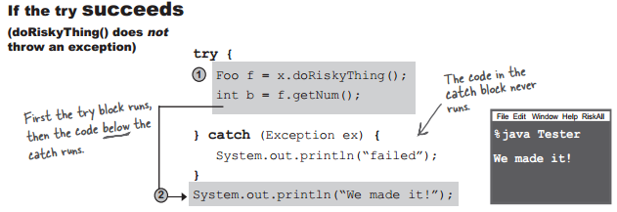

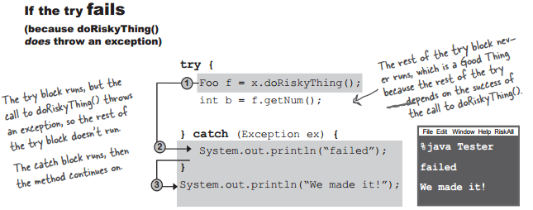

**Finally: for the things you want to do no matter what.**

If you try to cook something, you start by turning on the oven.

If the thing you try is a complete failure, you have to turn off the oven.

If the thing you try succeeds, you have to turn off the oven.

You have to turn off the oven no matter what!

A finally block is where you put code that must run regardless of an exception.

try {

turnOvenOn();

x.bake();

} catch (BakingException ex) {

ex.printStackTrace();

} finally {

turnOvenOff();

}

A method can throw multiple exceptions if it darn well needs to. But a method’s declaration must declare all the checked exceptions it can throw (although if two or more exceptions have a common superclass, the method can declare just the superclass.)

**Catching multiple exceptions**

The compiler will make sure that you’ve handled all the checked exceptions thrown by the method you’re calling. Stack the catch blocks under the try, one after the other. Sometimes the order in which you stack the catch blocks matters, but we’ll get to that a little later.

**Exceptions are polymorphic**

-You can DECLARE exceptions using a supertype of the exceptions you throw.

-You can CATCH exceptions using a supertype of the exception thrown.

Just because you CAN catch everything with one big super polymorphic catch, doesn’t always mean you SHOULD. Write a different catch block for each exception that you need to handle uniquely.

Multiple catch blocks must be ordered from smallest to biggest



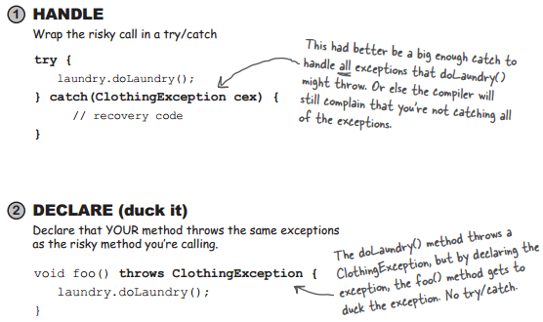

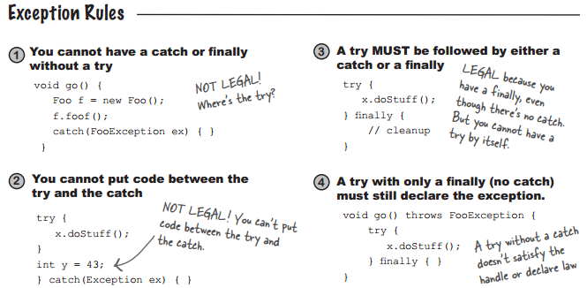

1. throws clause is used to declare an exception and throw keyword is used to throw an exception explicitly.
2. If we see syntax wise then throw is followed by an instance variable and throws is followed by exception class names.
3. The keyword throw is used inside method body to invoke an exception and throws clause is used in method declaration (signature).

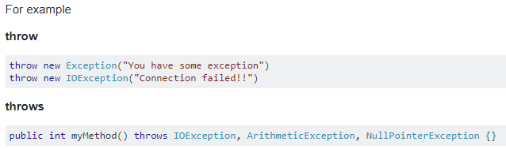

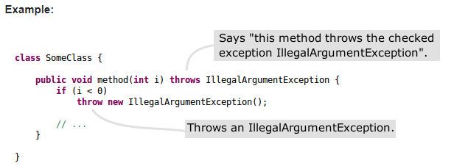

* **serialization and file I/O**

If your data will be used by only the Java program that generated it: Use **serialization**

Write a file that holds flattened (serialized) objects. Then have your program read the serialized objects from the file and inflate them back into living, breathing, heap-inhabiting objects.

If your data will be used by other programs: Write a plain **text file**

Write a file, with delimiters that other programs can parse. For example, a tab-delimited file that a spreadsheet or database application can use.

**Writing a serialized object to a file**

1. Make a FileOutputStream

FileOutputStream fileStream = new FileOutputStream(“MyGame.ser”);

1. Make an ObjectOutputStream

ObjectOutputStream os = new ObjectOutputStream(fileStream);

1. Write the object

os.writeObject(characterOne);

os.writeObject(characterTwo);

os.writeObject(characterThree);

1. Close the ObjectOutputStream

os.close();

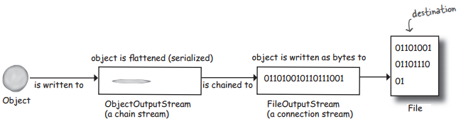

Serialization saves the entire object graph. All objects referenced by instance variables, starting with the object being serialized.

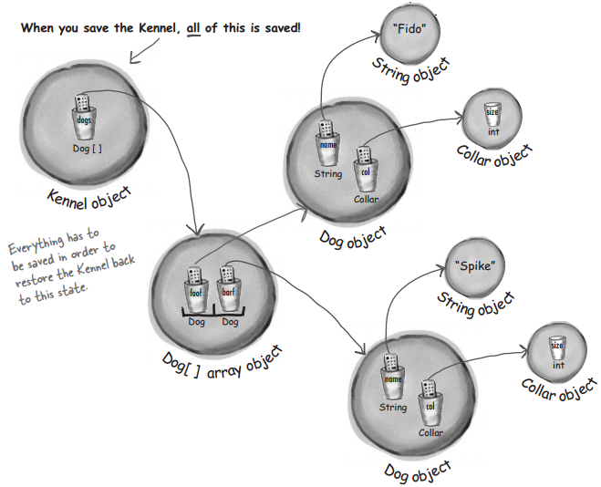

If you want your class to be serializable, implement **Serializable.**

Mark an instance variable as **transient** if it can’t (or shouldn’t) be saved.

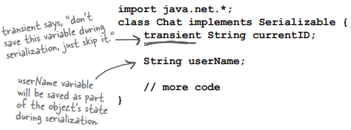

**Deserialization: restoring an object**

1. Make a FileInputStream

FileInputStream fileStream = new FileInputStream(“MyGame.ser”);

1. Make an ObjectInputStream

ObjectInputStream os = new ObjectInputStream(fileStream);

1. read the objects

Object one = os.readObject();

Object two = os.readObject();

Object three = os.readObject();

1. Cast the objects

GameCharacter elf = (GameCharacter) one;

GameCharacter troll = (GameCharacter) two;

GameCharacter magician = (GameCharacter) three;

1. Close the ObjectInputStream

os.close();

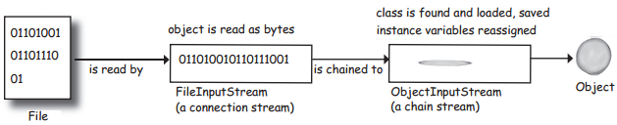

import java.io.*;

public class GameSaverTest {

public static void main(String[] args) {

GameCharacter one = new GameCharacter(50, “Elf”, new String[] {“bow”, “sword”, “dust”});

GameCharacter two = new GameCharacter(200, “Troll”, new String[] {“bare hands”, “big ax”});

GameCharacter three = new GameCharacter(120, “Magician”, new String[] {“spells”, “invisibility”});

// imagine code that does things with the characters that might //change their state values

try {

ObjectOutputStream os = new ObjectOutputStream(new FileOutputStream(“Game.ser”));

os.writeObject(one);

os.writeObject(two);

os.writeObject(three);

os.close();

} catch(IOException ex) {

ex.printStackTrace();

}

one = null;

two = null;

three = null;

try {

ObjectInputStream is = new ObjectInputStream(new FileInputStream(“Game.ser”));

GameCharacter oneRestore = (GameCharacter) is.readObject();

GameCharacter twoRestore = (GameCharacter) is.readObject();

GameCharacter threeRestore = (GameCharacter) is.readObject();

System.out.println(“One’s type: “ + oneRestore.getType());

System.out.println(“Two’s type: “ + twoRestore.getType());

System.out.println(“Three’s type: “ + threeRestore.getType());

} catch(Exception ex) {

ex.printStackTrace();

}

}

}

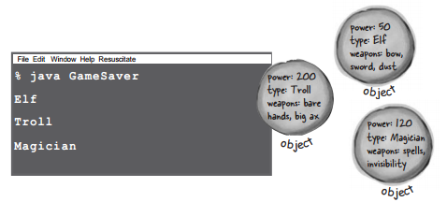

import java.io.*;

public class GameCharacter implements Serializable {

int power;

String type;

String[] weapons;

public GameCharacter(int p, String t, String[] w) {

power = p;

type = t;

weapons = w;

}

public int getPower() {

return power;

}

public String getType() {

return type;

}

public String getWeapons() {

String weaponList = “”;

for (int i = 0; i < weapons.length; i++) {

weaponList += weapons[i] + “ “;

}

return weaponList;

}

}

* transient

The transient keyword in Java is used to indicate that a field should not be serialized.

import java.io.*;

class DungeonGame implements Serializable {

public int x = 3;

transient long y = 4;

private short z = 5;

int getX() {

return x;

}

long getY() {

return y;

}

short getZ() {

return z;

}

}

class DungeonTest {

public static void main(String [] args) {

DungeonGame d = new DungeonGame();

System.out.println(d.getX() + d.getY() + d.getZ());

try {

FileOutputStream fos = new FileOutputStream(“dg.ser”);

ObjectOutputStream oos = new ObjectOutputStream(fos);

oos.writeObject(d);

oos.close();

FileInputStream fis = new FileInputStream(“dg.ser”);

ObjectInputStream ois = new ObjectInputStream(fis);

d = (DungeonGame) ois.readObject();

ois.close();

} catch (Exception e) {

e.printStackTrace();

}

System.out.println(d.getX() + d.getY() + d.getZ());

}

}

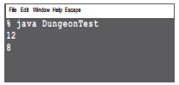

**Writing a String to a Text File**

To write a serialized object:

objectOutputStream.writeObject(someObject);

To write a String:

fileWriter.write(“My first String to save”);

import java.io.*;

class WriteAFile {

public static void main (String[] args) {

try {

File myFile = new File(“MyText.txt”);

FileWriter fileWriter = new FileWriter (myFile);

BufferedWriter writer = new BufferedWriter (fileWriter);

writer.write(“hello!”);

writer.close();

} catch(IOException ex) {

ex.printStackTrace();

}

}

}

**Some things you can do with a File object:**

1. Make a File object representing an existing file

File f = new File(“MyCode.txt”);

1. Make a new directory

File dir = new File(“Chapter7”);

dir.mkdir();

1. List the contents of a directory

if (dir.isDirectory()) {

String[] dirContents = dir.list();

for (int i = 0; i < dirContents.length; i++) {

System.out.println(dirContents[i]);

}

}

1. Get the absolute path of a file or directory

System.out.println(dir.getAbsolutePath());

1. Delete a file or directory (returns true if successful)

boolean isDeleted = f.delete();

**Reading from a Text File**

import java.io.*;

class ReadAFile {

public static void main (String[] args) {

try {

File myFile = new File(“MyText.txt”);

FileReader fileReader = new FileReader(myFile);

BufferedReader reader = new BufferedReader(fileReader);

String line = null;

while ((line = reader.readLine()) != null) {

System.out.println(line);

}

reader.close();

} catch(Exception ex) {

ex.printStackTrace();

}

}

}



String toTest = “What is blue + yellow?/green”;

String[] result = toTest.split(“/”);

for (String token:result) {

System.out.println(token);

}

**Difference between StringBuffer and StringBuilder**

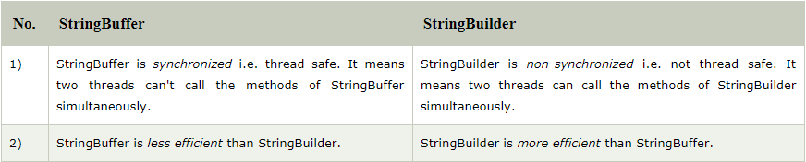

StringBuilder str = new StringBuilder("tutorials ");

System.out.println("string = " + str);

// appends the string argument to the StringBuilder

str.append("point");

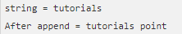// print the StringBuilder after appending

System.out.println("After append = " + str);

* **networking and threads**

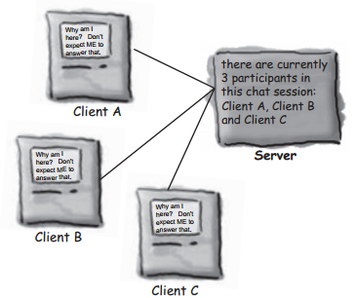

Connecting, Sending, and Receiving

The three things we have to learn to get the client working are :

1) How to establish the initial connection between the client and server

2) How to send messages to the server

3) How to receive messages from the server

To make a Socket connection, you need to know two things about the server: who it is, and which port

it’s running on.

In other words, IP address and TCP port number.

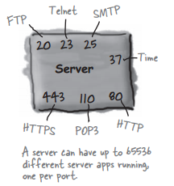

The TCP port numbers from 0 to 1023 are reserved for well known services. Don’t use them for your

own server programs!

**To read data from a Socket, use a BufferedReader**

1. Make a Socket connection to the server

Socket chatSocket = new Socket(“127.0.0.1”, 5000);

//127.0.0.1 is the IP address for “localhost”

1. Make an InputStreamReader chained to the Socket’s low-level (connection) input stream

InputStreamReader stream = new InputStreamReader(chatSocket.getInputStream());

1. Make a BufferedReader and read!

BufferedReader reader = new BufferedReader(stream);

String message = reader.readLine();

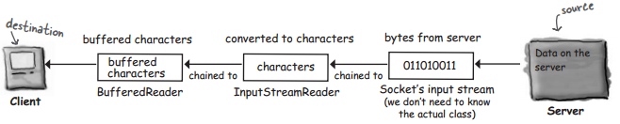

**To write data to a Socket, use a PrintWriter**

1. Make a Socket connection to the server

Socket chatSocket = new Socket(“127.0.0.1”, 5000);

1. Make a PrintWriter chained to the Socket’s low-level (connection) output stream

PrintWriter writer = new PrintWriter(chatSocket.getOutputStream());

1. Write (print) something

writer.println(“message to send”);

writer.print(“another message”);

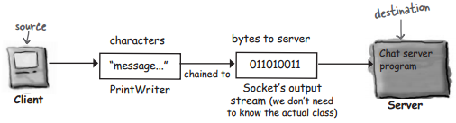

**DailyAdviceClient code**

import java.io.*;

import java.net.*;

public class DailyAdviceClient {

public void go() {

try {

Socket s = new Socket(“127.0.0.1”, 4242);

InputStreamReader streamReader = new InputStreamReader(s.getInputStream());

BufferedReader reader = new BufferedReader(streamReader);

String advice = reader.readLine();

System.out.println(“Today you should: “ + advice);

reader.close();

} catch(IOException ex) {

ex.printStackTrace();

}

}

public static void main(String[] args) {

DailyAdviceClient client = new DailyAdviceClient();

client.go();

}

}

**DailyAdviceServer code**

import java.io.*;

import java.net.*;

public class DailyAdviceServer {

String[] adviceList = {“Take smaller bites”, “Go for the tight jeans. No they do NOT make you look fat.”, “One word: inappropriate”, “Just for today, be honest. Tell your boss what you *really* think”, “You might want to rethink that haircut.”};

public void go() {

try {

ServerSocket serverSock = new ServerSocket(4242);

while(true) {

Socket sock = serverSock.accept();

PrintWriter writer = new

PrintWriter(sock.getOutputStream());

String advice = getAdvice();

writer.println(advice);

writer.close();

System.out.println(advice);

}

} catch(IOException ex) {

ex.printStackTrace();

}

} // close go

private String getAdvice() {

int random = (int) (Math.random() * adviceList.length);

return adviceList[random];

}

public static void main(String[] args) {

DailyAdviceServer server = new DailyAdviceServer();

server.go();

}

}

A thread is a separate ‘thread of execution’. In other words, a separate call stack.

A Thread is a Java class that represents a thread.To make a thread, make a Thread.

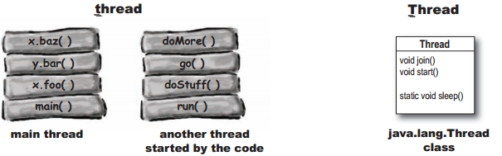

**Every Thread needs a job to do. A method to put on the new thread stack.**

*Runnable is to a Thread what a job is to a worker. A Runnable is the job a thread is*

*supposed to run.*

*A Runnable holds the method that goes on the bottom of the new thread’s stack: run().*

**public void run() {**

**// code that will be run by the new thread**

**}**

When you pass a Runnable to a Thread constructor, you’re really just giving the Thread a way to get to a run() method. You’re giving the Thread its job to do.

To make a job for your thread, implement the Runnable interface

public class MyRunnable implements Runnable {

public void run() {

go();

}

public void go() {

doMore();

}

public void doMore() {

System.out.println(“top o’ the stack”);

}

}

class ThreadTester {

public static void main (String[] args) {

Runnable threadJob = new MyRunnable();

Thread myThread = new Thread(threadJob);

myThread .start();

System.out.println(“back in main”);

}

}

try {

Thread.sleep(2000);

} catch(InterruptedException ex) {

ex.printStackTrace();

}

public class RunThreads implements Runnable {

public static void main(String[] args) {

RunThreads runner = new RunThreads();

Thread alpha = new Thread(runner);

Thread beta = new Thread(runner);

alpha.setName(“Alpha thread”);

beta.setName(“Beta thread”);

alpha.start();

beta.start();

}

public void run(){

for (int i = 0; i < 25; i++) {

String threadName = Thread.currentThread().getName();

System.out.println(threadName + “ is running”);

}

}

}

**/-----------------------------------------------**

**public** **class** RyanAndMonicaJob **implements** Runnable {

**private** BankAccount account = **new** BankAccount();

**public** **static** **void** main(String[] args) {

RyanAndMonicaJob theJob = **new** RyanAndMonicaJob();

Thread one = **new** Thread(theJob);

Thread two = **new** Thread(theJob);

one.setName("Ryan");

two.setName("Monica");

one.start();

two.start();

}

**public** **void** run() {

**for** (**int** x = 0; x < 10; x++) {

makeWithdrawal(10);

**if** (account.getBalance() < 0) {

System.*out*.println("Overdrawn!");

}

}

}

**private** **void** makeWithdrawal(**int** amount) {

**if** (account.getBalance() >= amount) {

System.*out*.println(Thread.*currentThread*().getName()

+ " is about to withdraw");

**try** {

System.*out*.println(Thread.*currentThread*().getName()

+ " is going to sleep");

Thread.*sleep*(500);

} **catch** (InterruptedException ex) {

ex.printStackTrace();

}

System.*out*.println(Thread.*currentThread*().getName()

+ "woke up.");

account.withdraw(amount);

System.*out*.println(Thread.*currentThread*().getName()

+ " completes the withdrawl");

} **else** {

System.*out*.println("Sorry, not enough for "

+ Thread.*currentThread*().getName());

}

}

}

We need the makeWithdrawal ( ) method to run as one atomic thing.

private synchronized void makeWithdrawal(int amount) {

if (account.getBalance() >= amount) {

System.out.println(Thread.currentThread().getName() + “ is about to withdraw”);

try {

System.out.println(Thread.currentThread().getName() + “ is going to sleep”);

Thread.sleep(500);

} catch(InterruptedException ex) {ex.printStackTrace(); }

System.out.println(Thread.currentThread().getName() + “ woke up.”);

account.withdraw(amount);

System.out.println(Thread.currentThread().getName() + “ completes the withdrawl”);

} else {

System.out.println(“Sorry, not enough for “ + Thread.currentThread().getName());

}

}



The synchronized keyword means that a thread needs a key in order to access the synchronized code.To protect your data(like the bank account), synchronize the methods that act on that data.

Every Java object has a lock. A lock has only one key.Most of the time, the lock is unlocked and nobody cares.But if an object has synchronized methods, a thread can enter one of the synchronized methods ONLY if the key for the object’s lock is available. In other words, only if another thread hasn’t already grabbed the one key.

# Thread States and Life Cycle

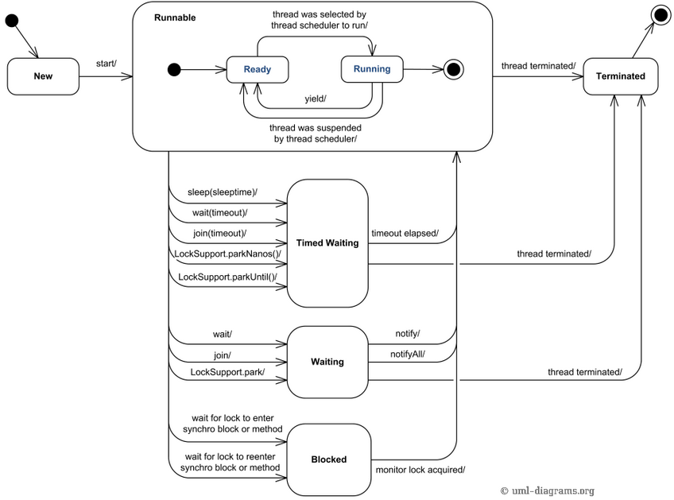

## Synchronized Statements

synchronized statements must specify the object that provides the intrinsic lock:

public void addName(String name) {

synchronized(this) {

lastName = name;

nameCount++;

}

nameList.add(name);

}

class Syn {

public void display() {

for (int i = 1; i < 10; i += 2) {

System.out.println(i);

try {

Thread.sleep(1000);

} catch (Exception ex) {

}

}

}

}

public class Nosyn extends Thread {

static Syn a = new Syn(); //Notice static

public void run() {

synchronized (a) {

a.display();

}

}

public static void main(String[] args) {

// TODO Auto-generated method stub

Nosyn m = new Nosyn();

Nosyn n = new Nosyn();

m.start();

n.start();

}

}

/***********************************************************/

public class ThreadDemo extends Thread {

public void run() {

for (int i = 0; i <= 10; i++)

System.out.println(i);

}

public static void main(String[] args) {

Thread thread = new ThreadDemo();

thread.start();

}

}

/***********************************************************/

thread.getId()

setPriority(int priority) //MIN_PRIORITY NORM_PRIORITY MAX_PRIORITY

Monitor (Java Virtual Machine) hay java monitor là 1 công cụ giám sát hỗ trợ cho việc đồng bộ hóa các luồng.

* **collections and generics**

A *collection* — sometimes called a container — is simply an object that groups multiple elements into a single unit. Collections are used to store, retrieve, manipulate, and communicate aggregate data. Typically, they represent data items that form a natural group, such as a poker hand (a collection of cards), a mail folder (a collection of letters), or a telephone directory (a mapping of names to phone numbers). If you have used the Java programming language — or just about any other programming language — you are already familiar with collections.

**The Collection API (part of it)**

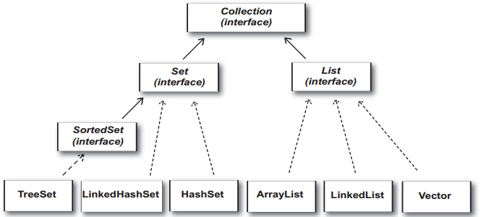

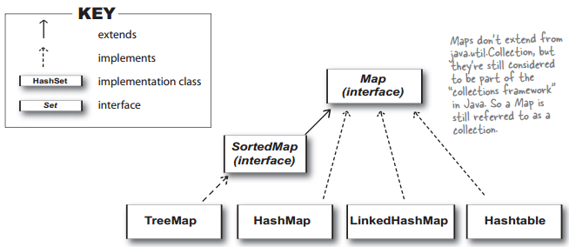

From the Collection API, we find three main interfaces, List, Set, and Map.

 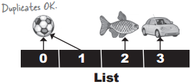

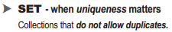 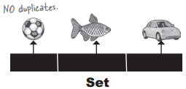

 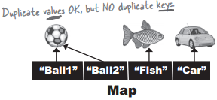

**Sets**

A *set* is probably the simplest kind of collection you can have. Here the objects are not ordered in any particular way at all, and objects are simply added to the set without any control over where they go. It's a bit like putting things in your pocket — you just put things in and they rattle around inside your pocket in no particular order but at least you know roughly where they are.

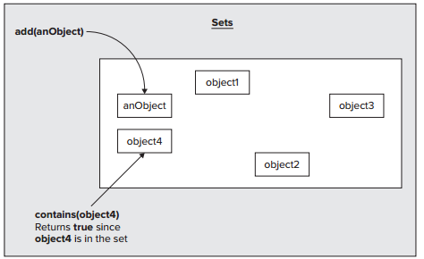

**Sequences**

The linked list that you have already explored to some extent is an example of a more general type of collection called a sequence. A primary characteristic of a sequence is that the objects are stored in a linear fashion, not necessarily in any particular order, but organized in an arbitrary fixed sequence with a beginning and an end. This contrasts with the set discussed in the previous section, where there may be no order at all. An ordinary array is basically another example of a sequence, but it is more limited than the equivalent collection because it holds a fixed number of elements.

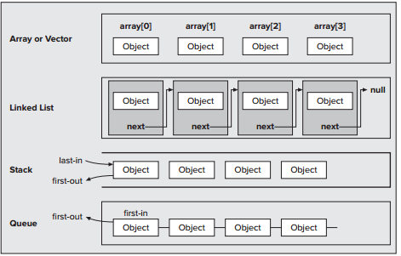

**Maps**

A *map* is rather different from a set or a sequence collection because each entry involves a pair of objects. A map is sometimes referred to as a *dictionary* because of the way it works. Each object that is stored in a map has an associated *key* object, and the object and its key are stored together as a pair. The key determines where the object is stored in the map, and when you want to retrieve an object, you must supply its key — so the key acts as the equivalent of a word that you look up in a regular dictionary.

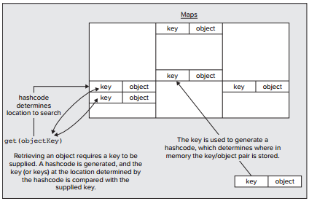

**Hashing**

Where a key/object pair is stored in a map is determined from the key by a process known as hashing. Hashing processes the key object to produce an integer value called a hashcode. A basic requirement for hashing is that you get the same hashcode from repeatedly hashing the same object.

**ITERATORS**

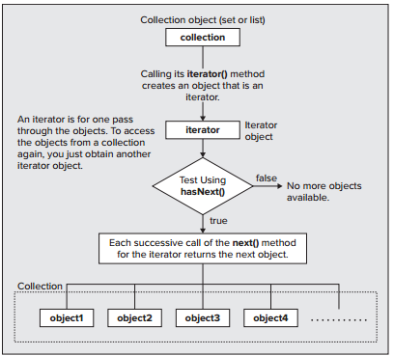

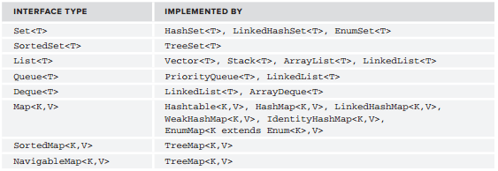

java.util.Collections

public static void copy(List destination, List source)

public static List emptyList()

public static void fill(List listToFill, Object objToFillItWith)

public static int frequency(Collection c, Object o)

public static void reverse(List list)

public static void rotate(List list, int distance)

public static void shuffle(List list)

public static void sort(List list)

Sort the songs in alphabetical order

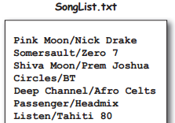

import java.util.*;

import java.io.*;

public class Jukebox1 {

ArrayList<String> songList = new ArrayList<String>();

public static void main(String[] args) {

new Jukebox1().go();

}

public void go(){

getSongs();

System.out.println(songList);

Collections.sort(songList);

System.out.println(songList);

}

void getSongs(){

try {

File file = new File(“SongList.txt”);

BufferedReader reader = new BufferedReader(new FileReader(file));

String line = null;

while ((line= reader.readLine()) != null) {

addSong(line);

}

} catch(Exception ex) {

ex.printStackTrace();

}

}

void addSong(String lineToParse){

String[] tokens = lineToParse.split(“/”);

songList.add(tokens[0]);

}

}

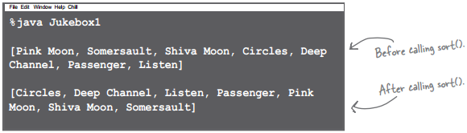

But now you need Song objects, not just simple Strings.

class Song{

String title;

String artist;

String rating;

String bpm;

Song(String t, String a, String r, String b) {

title = t;

artist = a;

rating = r;

bpm = b;

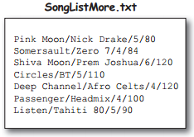 }

public String getTitle() {

return title;

}

public String getArtist() {

return artist;

}

public String getRating() {

return rating;

}

public String getBpm() {

return bpm;

}

public String toString() {

return title;

}

}

/******************************************************************/

import java.util.*;

import java.io.*;

public class Jukebox3 {

ArrayList<Song>songList = new ArrayList<Song>();

public static void main(String[] args) {

new Jukebox3().go();

}

public void go(){

getSongs();

System.out.println(songList);

Collections.sort(songList);

System.out.println(songList);

}

void getSongs(){

try {

File file = new File(“SongList.txt”);

BufferedReader reader = new BufferedReader(new FileReader(file));

String line = null;

while ((line= reader.readLine()) != null) {

addSong(line);

}

} catch(Exception ex) {

ex.printStackTrace();

}

}

void addSong(String lineToParse){

String[] tokens = lineToParse.split(“/”);

Song nextSong = new Song(tokens[0], tokens[1], tokens[2], tokens[3]);

songList.add(nextSong);

}

}

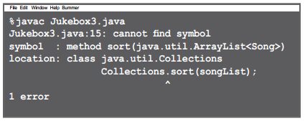

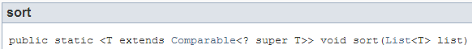

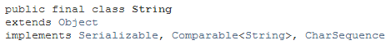

java.lang.Comparable

public interface Comparable<T> {

int compareTo(T o);

}

*Return: a negative integer, zero, or a positive integer as this object is less than, equal to, or greater than the specified object.*

// The Song class needs to implement Comparable

//Add and modify class Song

class Song implements Comparable<Song>

public int compareTo(Song s) {

return title.compareTo(s.getTitle());

}

Using a custom Comparator

java.util.Comparator

public interface Comparator<T> {

int compare(T o1, T o2);

}

Invoking the one-argument **sort(List o)** method means the list element’s compareTo() method determines the order. So the elements in the list MUST implement the Comparable interface.

Invoking **sort(List o, Comparator c)** means the listelement’s compareTo() method will NOT be called, and the Comparator’s compare() method will be used instead. That means the elements in the list do NOT need to implement the Comparable interface.

Two different views of the song list, one by song title and one by artist!

import java.util.*;

import java.io.*;

public class Jukebox5 {

ArrayList<Song> songList = new ArrayList<Song>();

public static void main(String[] args) {

new Jukebox5().go();

}

**class ArtistCompare implements Comparator<Song>{**

**public int compare(Song one, Song two) {**

**return one.getArtist().compareTo(two.getArtist());**

**}**

**}**

public void go() {

getSongs();

System.out.println(songList);

Collections.sort(songList);

System.out.println(songList); //sort by title

**ArtistCompare artistCompare = new ArtistCompare();**

**Collections.sort(songList, artistCompare);**

System.out.println(songList); //sort by artist

}

void getSongs() {

// I/O code here

}

void addSong(String lineToParse) {

// parse line and add to song list

}

}

import java.util.*;

public class SortMountains {

LinkedList<Mountain>mtn = new LinkedList<Mountain>();

class NameCompare implements Comparator <Mountain>{

public int compare(Mountain one, Mountain two) {

return one.name.compareTo(two.name);

}

}

class HeightCompare implements Comparator <Mountain>{

public int compare(Mountain one, Mountain two) {

return (two.height - one.height);

}

}

public static void main(String [] args) {

new SortMountains().go();

}

public void go() {

mtn.add(new Mountain(“Longs”, 14255));

mtn.add(new Mountain(“Elbert”, 14433));

mtn.add(new Mountain(“Maroon”, 14156));

mtn.add(new Mountain(“Castle”, 14265));

System.out.println(“as entered:\n” + mtn);

NameCompare nc = new NameCompare();

Collections.sort(mtn, nc);

System.out.println(“by name:\n” + mtn);

HeightCompare hc = new HeightCompare();

Collections.sort(mtn, hc);

System.out.println(“by height:\n” + mtn);

}

}

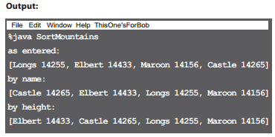class Mountain {

String name;

int height;

Mountain(String n, int h){

name = n;

height = h;

}

public String toString( ){

return name + “ “ + height;

}

}

**Generics means more type-safety**

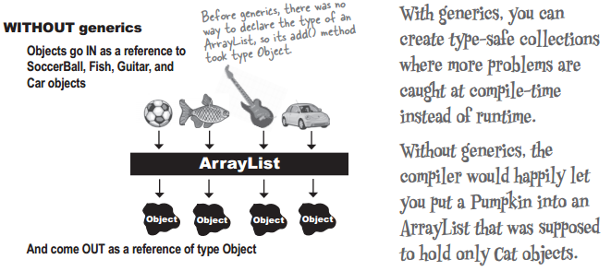

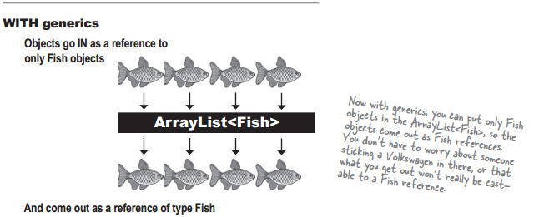

**Learning generics**

Of the dozens of things you could learn about generics, there are really only three that matter to most programmers:

1. Creating instances of generified classes(like ArrayList)

new ArrayList**<Song>**()

1. Declaring and assigning variables of generic types

List**<Song>** songList = new ArrayList**<Song>()**

1. Declaring (and invoking) methods that take generic types

void foo(List**<Song>** list)

x.foo(songList)

**Using generic CLASSES**

Think of “E” as a stand-in for “the type of element you want this collection to hold and

return.” (E is for Element.)

public class ArrayList**<E>** extends AbstractList**<E>** implements List**<E>**... {

public boolean add(**E** o)

// more code

}

**Using generic METHODS**

Using a type parameter defined in the class declaration

public class ArrayList**<E>** extends AbstractList**<E>**... {

public boolean add(**E** o)

Using a type parameter that was NOT defined in the class declaration(***T: any type of Animal***)

public **<T extends Animal>** void takeThing(ArrayList**<T>** list)

This:

public <T extends Animal>void takeThing(ArrayList<T>list)

Is NOT the same as this:

public void takeThing(ArrayList<Animal>list)

In generics, the keyword “**extends**” really means “**is-a**”, and works for BOTH **classes** and **interfaces**.

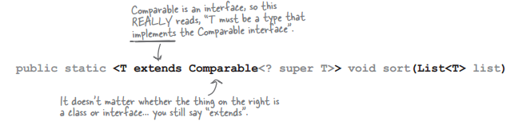

***T is must be of type Comparable,***

***The type parameter for Comparable must be ‘T’ or T’s supertype.***

Here’s how it works with **regular arrays**:

import java.util.*;

public class TestGenerics1 {

public static void main(String[] args) {

new TestGenerics1().go();

}

public void go() {

Animal[] animals = {new Dog(), new Cat(), new Dog()};

Dog[] dogs = {new Dog(), new Dog(), new Dog()};

takeAnimals(animals);

takeAnimals(dogs);

}

public void takeAnimals(Animal[] animals) {

for(Animal a: animals) {

a.eat();

}

}

}

The crucial point is that the takeAnimals() method can take an Animal[] or a Dog[], since Dog IS-A Animal. Polymorphism in action.

a.eat(): Remember, we can call ONLY the methods declared in type animal, since the animals parameter is of type Animal array, and we didn’t do any casting. (What would we cast it to? That array might hold both Dogs and Cats.)

abstract class Animal {

void eat() {

System.out.println(“animal eating”);

}

}

class Dog extends Animal {

void bark() { }

}

class Cat extends Animal {

void meow() { }

}

Using polymorphic arguments and generics

Passing in just ArrayList<Animal>

public void go() {

ArrayList<Animal> animals = new ArrayList<Animal>();

animals.add(new Dog());

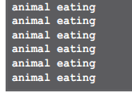animals.add(new Cat());

animals.add(new Dog());

takeAnimals(animals);

}

public void takeAnimals(ArrayList<Animal> animals){

for(Animal a: animals) {

a.eat();

}

}

Passing in just ArrayList<Dog>

public void go() {

ArrayList<Animal> animals = new ArrayList<Animal>();

animals.add(new Dog());

animals.add(new Cat());

animals.add(new Dog());

takeAnimals(animals);

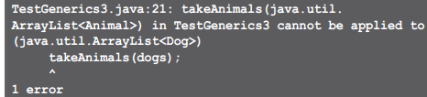ArrayList<Dog> dogs = new ArrayList<Dog>();

dogs.add(new Dog());

dogs.add(new Dog());

takeAnimals(dogs);

}

public void takeAnimals(ArrayList<Animal> animals){

for(Animal a: animals) {

a.eat();

} }

there is a way to create a method argument that can accept an ArrayList of any Animal subtype.

**takeAnimals(ArrayList<? extends Animal> animals)**

**The sorting all works, but now we have duplicates...**

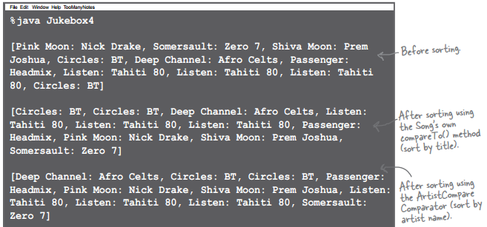

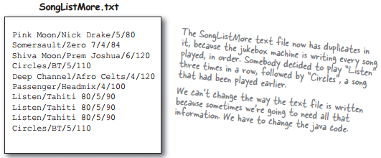

**Using a HashSet instead of ArrayList**

public class Jukebox6 {

ArrayList<Song> songList = new ArrayList<Song>();

// main method etc.

public void go() {

getSongs();

System.out.println(songList);

Collections.sort(songList);

System.out.println(songList);

HashSet<Song> songSet = new HashSet<Song>();

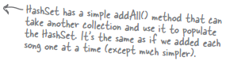songSet.addAll(songList);

System.out.println(songSet);

}

// getSongs() and addSong() methods

}

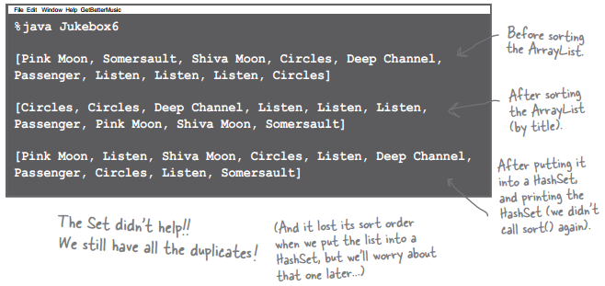

**What makes two objects equal ?**

First, we have to ask—what makes two Song references duplicates? They must be considered equal. Is it simply two references to the very same object, or is it two separate objects that both have the same title? This brings up a key issue: *reference* equality vs. *object* equality.

**If two objects foo and bar are equal,foo.equals(bar) must be true, and both foo and bar must**

**return the same value from hashCode(). For a Set to treat two objects as duplicates, you**

**must *override the hashCode() and equals() methods inherited from class Object*, so that you**

**can make two different objects be viewed as equal.**

 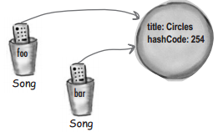

if (foo == bar) {

// both references are referring

// to the same object on the heap

}

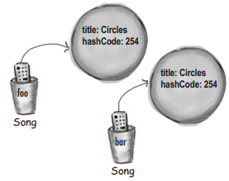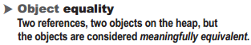

if (foo.equals(bar)&&

foo.hashCode() == bar.hashCode()) {

// both references are referring to either

// a single object, or to two objects that // are equal

}

**How a HashSet checks for duplicates: hashCode() and equals()**

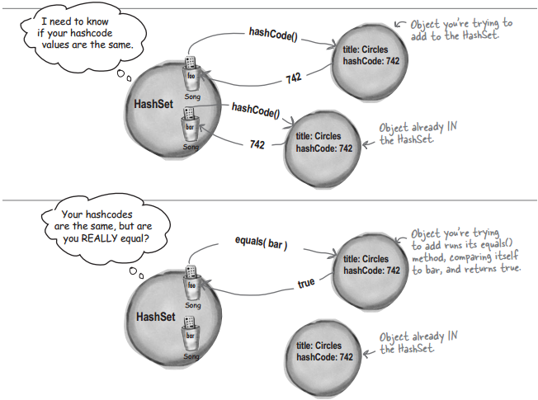

class Song implements Comparable<Song>{

String title;

String artist;

String rating;

String bpm;

public boolean equals(Object aSong){

Song s = (Song) aSong;

return getTitle().equals(s.getTitle());

}

public int hashCode(){

return title.hashCode();

}

public int compareTo(Song s) {

return title.compareTo(s.getTitle());

}

public String toString() {

return title;

}

//Constructor and getter

}

**Java Object Law For HashCode() and equals()**

The API docs for class Object state the rules you MUST follow:

-If two objects are equal, they MUST have matching hashcodes.

-If two objects are equal, calling equals() on either object MUST return true. In other words, if (a.equals(b)) then (b.equals(a)).

-If two objects have the same hashcode value, they are NOT required to be equal. But if they’re equal, they MUST have the same hashcode value.

-So, if you override equals(), you MUST override hashCode().

-The default behavior of hashCode() is to generate a unique integer for each object on the heap. So if you don’t override hashCode() in a class, no two objects of that type can EVER be considered equal.

-The default behavior of equals() is to do an == comparison. In other words, to test whether the two references refer to a single object on the heap. So if you don’t override equals() in a class, no two objects can EVER be considered equal since references to two different objects will always contain a different bit pattern.

a.equals(b)must also mean that a.hashCode() == b.hashCode()

But a.hashCode() == b.hashCode()does NOT have to mean a.equals(b)

**And if we want the set to stay sorted, we’ve got TreeSet**

TreeSet is similar to HashSet in that it prevents duplicates. But it also keeps the list sorted.

import java.util.*;

import java.io.*;

public class Jukebox8 {

ArrayList<Song> songList = new ArrayList<Song>();

int val;

public static void main(String[] args) {

new Jukebox8().go();

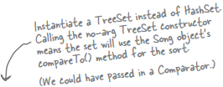}

public void go() {

getSongs();

System.out.println(songList);

Collections.sort(songList);

System.out.println(songList);

TreeSet<Song> songSet = new TreeSet<Song>();

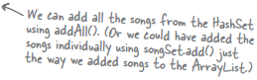songSet.addAll(songList);

System.out.println(songSet);

}

// getSongs() and addSong() methods

}

**What you MUST know about TreeSet...**

TreeSet looks easy, but make sure you really understand what you need to do to use it. We thought it was so important that we made it an exercise so you’d haveto think about it.

import java.util.*;

public class TestTree {

public static void main (String[] args) {

new TestTree().go();

}

public void go() {

Book b1 = new Book(“How Cats Work”);

Book b2 = new Book(“Remix your Body”);

Book b3 = new Book(“Finding Emo”);

TreeSet<Book> tree = new TreeSet<Book>();

tree.add(b1);

tree.add(b2);

tree.add(b3);

System.out.println(tree);

}

}

class Book {

String title;

public Book(String t) {

title = t;

}

}

1). What is the result when you compile this code?

2). If it compiles, what is the result when you run the TestTree class?

3). If there is a problem (either compile-time or runtime) with this code, how would you fix it?

**TreeSet elements MUST be comparable**

To use a TreeSet, one of these things must be true:

**-The elements in the list must be of a type that implements Comparable**

class Book implements Comparable{

String title;

public Book(String t) {

title = t;

}

public int compareTo(Object b) {

Book book = (Book) b;

return (title.compareTo(book.title));

}

}

**OR**

**-You use the TreeSet’s overloaded constructor that takes a Comparator**

public class BookCompare implements Comparator<Book> {

public int compare(Book one, Book two) {

return (one.title.compareTo(two.title));

}

}

class Test {

public void go() {

Book b1 = new Book(“How Cats Work”);

Book b2 = new Book(“Remix your Body”);

Book b3 = new Book(“Finding Emo”);

BookCompare bCompare = new BookCompare();

TreeSet<Book> tree = new TreeSet<Book>(bCompare);

tree.add(new Book(“How Cats Work”);

tree.add(new Book(“Finding Emo”);

tree.add(new Book(“Remix your Body”);

System.out.println(tree);

for(Book b : tree)

System.out.println(b.title);

}

}

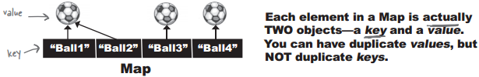

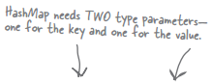

import java.util.*;

public class TestMap {

public static void main(String[] args) {

HashMap<String, Integer>scores = new HashMap<String, Integer>();

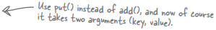scores.put(“Kathy”, 42);

scores.put(“Bert”, 343);

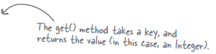scores.put(“Skyler”, 420);

System.out.println(scores);

System.out.println(**scores.get(“Bert”)**);

}

}

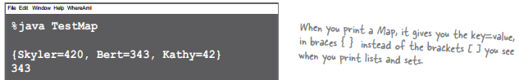

# Nested Classes

Nested classes are divided into two categories: static and non-static. Nested classes that are declared static are called *static nested classes*. Non-static nested classes are called *inner classes*.

class OuterClass {

...

static class StaticNestedClass {

...

}

class InnerClass {

...

}

}

A nested class is a member of its enclosing class. Non-static nested classes (inner classes) have access to other members of the enclosing class, even if they are declared private. Static nested classes do not have access to other members of the enclosing class. As a member of the OuterClass, a nested class can be declared private, public,protected, or *package private*. (Recall that outer classes can only be declared public or *package private*.)

**Compelling reasons for using nested classes include the following:**

It is a way of logically grouping classes that are only used in one place

It increases encapsulation

It can lead to more readable and maintainable code

* **static nested classes**

As with class methods and variables, a static nested class is associated with its outer class. And like static class methods, a static nested class cannot refer directly to instance variables or methods defined in its enclosing class: it can use them only through an object reference.

To create an object for the static nested class, use this syntax:

OuterClass.StaticNestedClass nestedObject = new

OuterClass.StaticNestedClass();

* **inner classes**

As with instance methods and variables, an inner class is associated with an instance of its enclosing class and has direct access to that object's methods and fields. Also, because an inner class is associated with an instance, it cannot define any static members itself.

To instantiate an inner class, you must first instantiate the outer class. Then, create the inner object within the outer object with this syntax:

OuterClass.InnerClass innerObject = outerObject.new InnerClass();

/* Java program to demonstrate how to implement static and non-static classes in a java program. */

**class** OuterClass {

**private** **static** String *msg* = "Hello";

// Static nested class

**public** **static** **class** NestedStaticClass {

// Only static members of Outer class is directly accessible in nested

// static class

**public** **void** printMessage() {

// Try making 'message' a non-static variable, there will be

// compiler error

System.*out*.println("Message from nested static class: " + *msg*);

}

}

// non-static nested class - also called Inner class

**public** **class** InnerClass {

// Both static and non-static members of Outer class are accessible in

// this Inner class

**public** **void** display() {

System.*out*.println("Message from non-static nested class: " + *msg*);

}

}

}

**class** Main {

// How to create instance of static and non static nested class?

**public** **static** **void** main(String args[]) {

// create instance of nested Static class

OuterClass.NestedStaticClass printer = **new** OuterClass.NestedStaticClass();

// call non static method of nested static class

printer.printMessage();

// In order to create instance of Inner class we need an Outer class

// instance. Let us create Outer class instance for creating

// non-static nested class

OuterClass outer = **new** OuterClass();

OuterClass.InnerClass inner = outer.**new** InnerClass();

// calling non-static method of Inner class

inner.display();

// we can also combine above steps in one step to create instance of

// Inner class

OuterClass.InnerClass innerObject = **new** OuterClass().**new** InnerClass();

// similarly we can now call Inner class method

innerObject.display();

}

}

* **Anonymous classes**

Anonymous classes enable you to make your code more concise. They enable you to declare and instantiate a class at the same time. They are like local classes except that they do not have a name. Use them if you need to use a local class only once.

The anonymous class expression consists of the following:

* The new operator
* The name of an interface to implement or a class to extend.
* Parentheses that contain the arguments to a constructor, just like a normal class instance creation expression. Note: When you implement an interface, there is no constructor, so you use an empty pair of parentheses.
* A body, which is a class declaration body. More specifically, in the body, method declarations are allowed but statements are not.

button.addActionListener(**new** ActionListener() {

@Override

**public** **void** actionPerformed(ActionEvent arg0) {

System.*out*.println("Hello");

}

});

* **Multidimensional Arrays**

**Working with multidimensional arrays**

- To access the second element in the third array: int x = a2d[2][1]; // remember, 0 based!

- To make a one-dimensional reference to one of the sub-arrays: int[] copy = a2d[1];

- Short-cut initialization of a 2 x 3 array: int[][] x = { { 2,3,4 }, { 7,8,9 } };

- To make a 2d array with irregular dimensions:

int[][] y = new int [2][]; // makes only the first array, with a length of 2

y[0] = new int [3]; // makes the first sub-array 3 elements in length

y[1] = new int [5]; // makes the second sub-array 5 elements in length

* ArrayList

add(Object elem) Appends the specified element to the end of this list.

add(int index, Object o) Inserts the specified element at the specified position.

remove(int index) Removes the object at the index parameter.

remove(Object elem) Removes this object (if it’s in the ArrayList).

contains(Object elem) Returns ‘true’ if there’s a match for the object parameter

isEmpty() Returns ‘true’ if the list has no elements

indexOf(Object elem) Returns either the index of the object parameter, or -1

size() Returns the number of elements currently in the list

get(int index) Returns the object currently at the index parameter

**class** Shape {

**public** **void** draw() {

System.***out***.println("Drawing a shape.");

}

}

**class** Circle **extends** Shape {

**public** **void** draw() {

System.***out***.println("Drawing a Circle.");

}

}

**class** Square **extends** Shape {

**public** **void** draw() {

System.***out***.println("Drawing a Square.");

}

}

**class** Triangle **extends** Shape {

**public** **void** draw() {

System.***out***.println("Drawing a Triangle.");

}

}

**public** **class** Polymorphism {

**public** **static** **void** main(String[] args) {

Shape shape = **new** Shape();

shape.draw();

}

} // Running this example gives you this: Drawing a shape

**public** **class** Polymorphism {

**public** **static** **void** main(String[] args) {

Shape shape = **new** Circle();

shape.draw();

}

} // Running this code gives you: Drawing a Circle.

**package** j2se.edu;

**public** **class** Person {

// 1. Create class's static, final, attribute

**public** **static** **final** String *FIRSTNAME* = "abc";

**public** **static** **final** String *LASTNAME* = "abc";

**public** **static** **final** **byte** *AGE* = (**byte**) 0;

**private** String firstName;

**private** String lastName;

**private** **byte** age;

**public** **static** **int** *count* = 0;

// 2.Create constructor(full att) method --> create other constructor

**public** Person() {

**this**(Person.*FIRSTNAME*, Person.*LASTNAME*, Person.*AGE*);

}

**public** Person(**byte** age) {

**this**(Person.*FIRSTNAME*, Person.*LASTNAME*, age);

}

**public** Person(String firstName, String lastName, **byte** age) {

**this**.firstName = firstName;

**this**.lastName = lastName;

**this**.age = age;

Person.*count*++;

}

// 3. Create getter/ setter method

**public** String getFirstName() {

**return** firstName;

}

**public** String getLastName() {

**return** lastName;

}

**public** **byte** getAge() {

**return** age;

}

**public** **static** **int** getCount() {

**return** Person.*count*;

}

// return this; ngan ko huy vung nho --> tiet kiem thoi gian khoi tao //va huy vung nho

**public** Person setFirstName(String firstName) {

**this**.firstName = firstName;

**return** **this**;

}

**public** Person setLastName(String lastName) {

**this**.lastName = lastName;

**return** **this**;

}

**public** Person setAge(**byte** age) {

**this**.age = age;

**return** **this**;

}

// 4. Create toString method

**public** String toString() {

**return** lastName + " " + firstName + " :" + age;

}

// 5.Other method

// static la thanh phan cua lop (ko phai la cua doi tuong)

**public** **static** **void** main(String[] args) {

// **TODO** Auto-generated method stub

Person p = **new** Person();

// p.setAge((byte)20);

// p.setFirstName("A");

// p.setLastName("Nguyen");

p.setAge((**byte**) 20).setFirstName("A").setLastName("Nguyen");

System.*out*.println(p.toString());

System.*out*.println(Person.*getCount*());

}

}

**Book:**

Head First Java

<http://docs.oracle.com/javase/tutorial/>

# Introducing the Streams API

The Streams API is a set of operations we can perform on a collection, so when we read these operations in our code, we can understand what we’re trying to do with the collection data.

Stream methods that return another Stream are called **Intermediate Operations**. These are instructions of things to do, but they don’t actually perform the operation on their own.

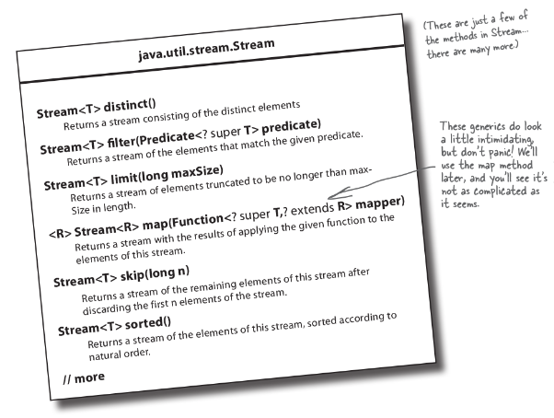

But you do need to call one of the Stream’s “do it” methods in order to get the result you want. These “do it” methods are called **Terminal Operations**, and these are the methods that will actually return something to you.

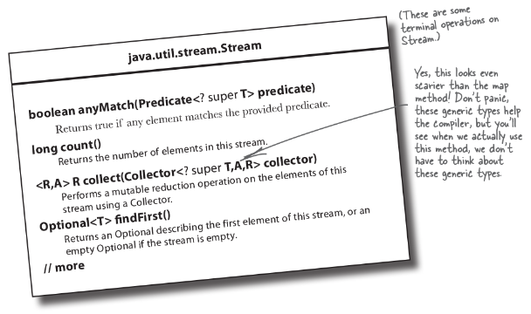

# Getting a result from a Stream

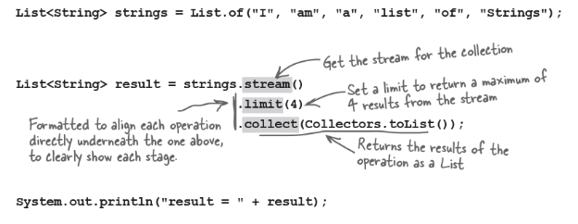

# Stream operations are building blocks

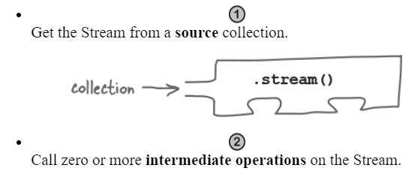

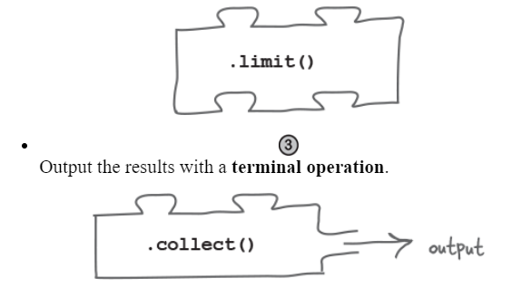

You need at least the **first** and **last** pieces of the puzzle to use the Streams API.

Every intermediate operation acts on a Stream and returns a Stream. That means you can stack together as many of these operations as you want, before calling a terminal operation to output the results.

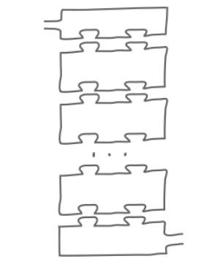

**NOTE:** The source, the intermediate operation(s), and the terminal operation all combine to form a **Stream Pipeline**. This pipeline represents a query on the original collection.

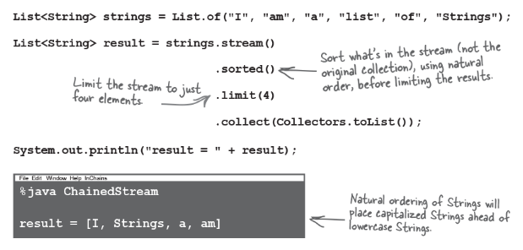

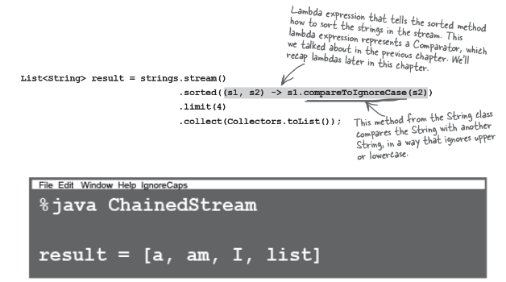

## Stream operations don’t change the original collection.

The Streams API is a way to query a collection, but it **doesn’t make changes** to the collection itself. You can use the Streams API to look through that collection and return results based on the contents of the collection, but your original collection will remain the same as it was.

### Lambda expressions are objects, and you run them by calling their Single Abstract Method

Remember, everything in Java is an Object (well, except for the primitive types), and lambdas are no exception.

**Note:** A lambda expression implements a Functional Interface.

This means the reference to the lambda expression is going to be a Functional Interface. So, if you want your method to accept a lambda expression, you need to have a parameter whose type is a functional interface. Remember, Functional Interfaces have a Single Abstract Method (SAM). It’s this method, whatever its name is, that gets called when we want to run the lambda code.

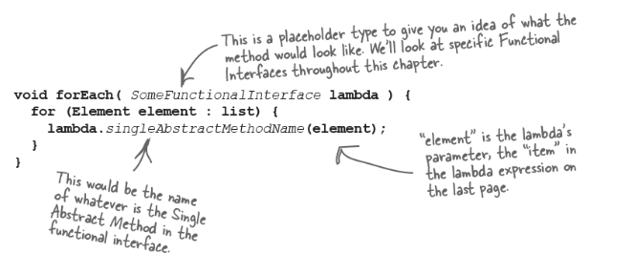

**NOTE: Lambdas aren’t magic; they’re just classes like everything else.**

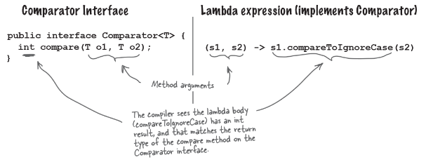

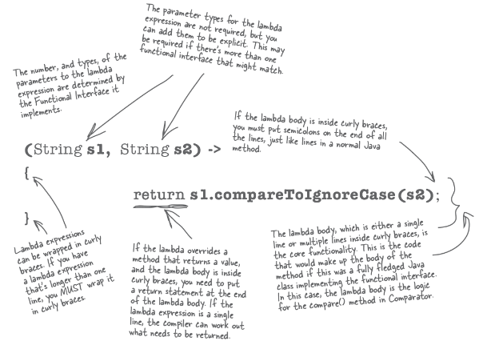

You might be wondering where the **return** keyword is in the lambda expression. The short version is: you don’t need it. The longer version is, if the lambda expression is a single line, and if the functional interface’s method signature requires a returned value, the compiler just assumes that your one line of code will generate the value that is to be returned.

## A lambda might have zero, one, or many parameters

The number of parameters the lambda expression needs is dependent upon the number of parameters the Functional Interface’s method takes. The parameter types (e.g., the name “String”) are not usually required, but you can add them if you think it makes it easier to understand the code. You may need to add the types if the compiler can’t automatically work out which Functional Interface your lambda implements.

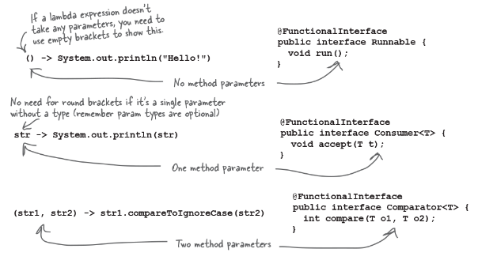

A lambda expression is composed of parameters, an arrow, and a body

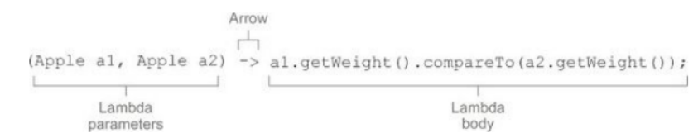

* A list of parameters— In this case it mirrors the parameters of the compare method of a Comparator—two Apples.
* An arrow— The arrow -> separates the list of parameters from the body of the lambda.
* The body of the lambda— Compare two Apples using their weights. The expression is considered the lambda’s return value.

The basic syntax of a lambda is either

(parameters) -> expression

or (note the curly braces for statements)

(parameters) -> { statements; }

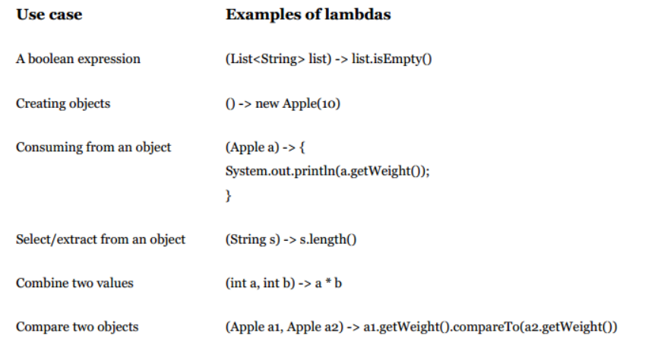

# Spotting Functional Interfaces

So far we’ve seen Functional Interfaces that are marked with a **@FunctionalInterface** annotation, which conveniently tells us this interface has a *Single Abstract Method* and can be implemented with a *lambda expression*.

Originally, the only kind of methods allowed in interfaces were **abstract** methods, methods that need to be overridden by any class that implements this interface. But as of Java 8, interfaces can also contain **default** and **static** methods.

Both default and static methods have a method body, with defined behavior. With interfaces, any method that is not defined as **default** or **static** is an abstract method that must be overridden.

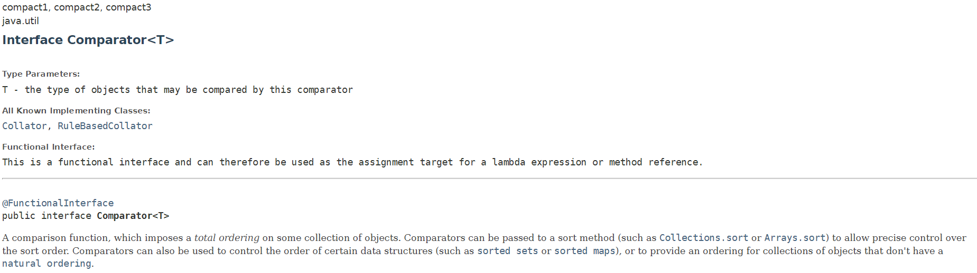

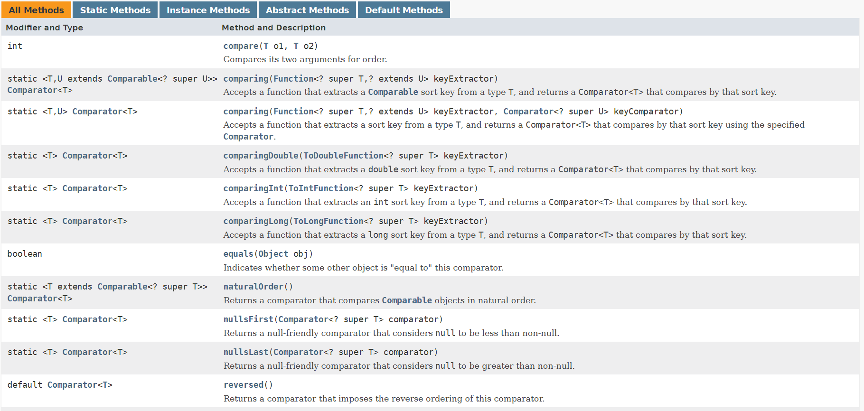

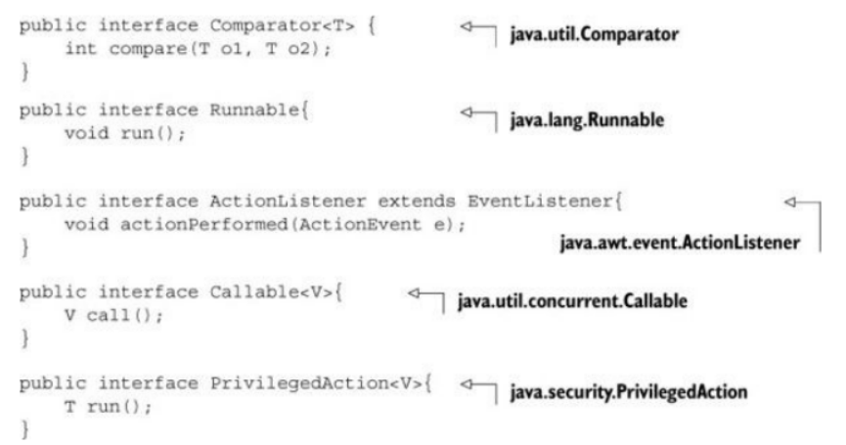

**Function descriptor**

The signature of the abstract method of the functional interface essentially describes the signature of the lambda expression. We call this abstract method a function descriptor. For example, the Runnable interface can be viewed as the signature of a function that accepts nothing and returns nothing (void) because it has only one abstract method called run, which accepts nothing and returns nothing (void).

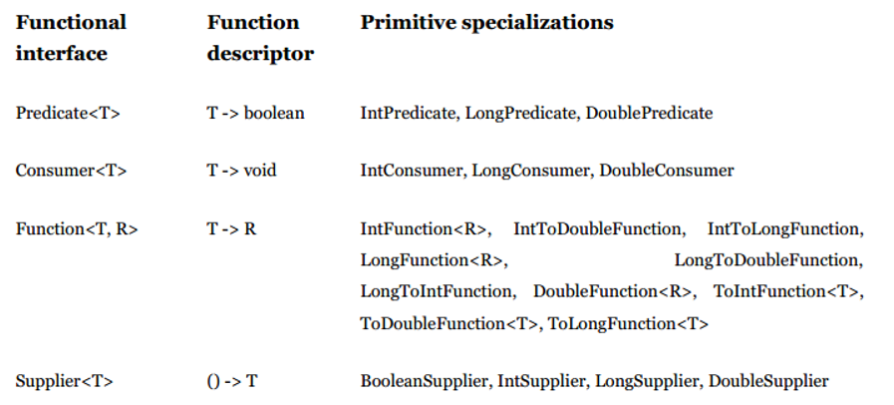

**Examples of lambda with function interfaces**

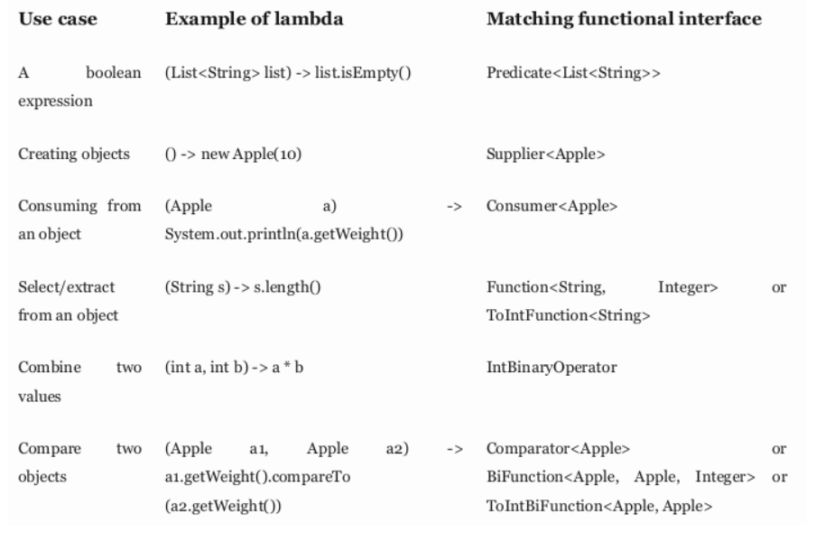

**Method references**

Method references let you reuse existing method definitions and pass them just like lambdas. In some cases they appear more readable and feel more natural than using lambda expressions.

Before:

inventory.sort((Apple a1, Apple a2) -> a1.getWeight().compareTo(a2.getWeight()));

After (using a method reference and java.util.Comparator.comparing):



**In a nutshell**

Why should you care about method references? Method references can be seen as shorthand for lambdas calling only a specific method. The basic idea is that if a lambda represents “call this method directly,” it’s best to refer to the method by name rather than by a description of how to call it. Indeed, a method reference lets you create a lambda expression from an existing method implementation. But by referring to a method name explicitly, your code can gain better readability. How does it work? When you need a method reference, the target reference is placed before the delimiter :: and the name of the method is provided after it.

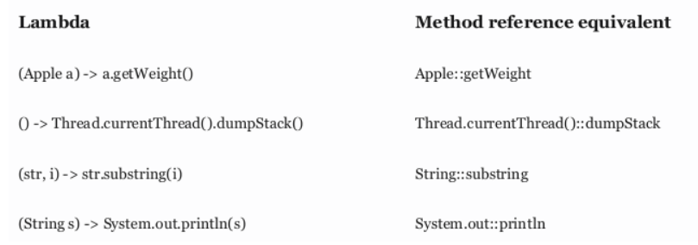

**Recipe for constructing method references**

There are three main kinds of method references:

1. A method reference to a static method (for example, the method parseInt of Integer, written Integer::parseInt)

2. A method reference to an instance method of an arbitrary type (for example, the method length of a String, written String::length)

3. A method reference to an instance method of an existing object (for example, suppose you have a local variable expensiveTransaction that holds an object of type Transaction, which supports an instance method getValue; you can write expensiveTransaction::getValue)

    The second and third kinds of method references may be a bit overwhelming at first. The idea with the second kind of method references such as String::length is that you’re referring to a method to an object that will be supplied as one of the parameters of the lambda. For example, the lambda expression (String s) -> s.toUpperCase() can be rewritten as String::toUpperCase. But the third kind of method references refers to a situation when you’re calling a method in a lambda to an external object that already exists. For example, the lambda expression () -> expensiveTransaction.getValue() can be rewritten as expensiveTransaction::getValue.

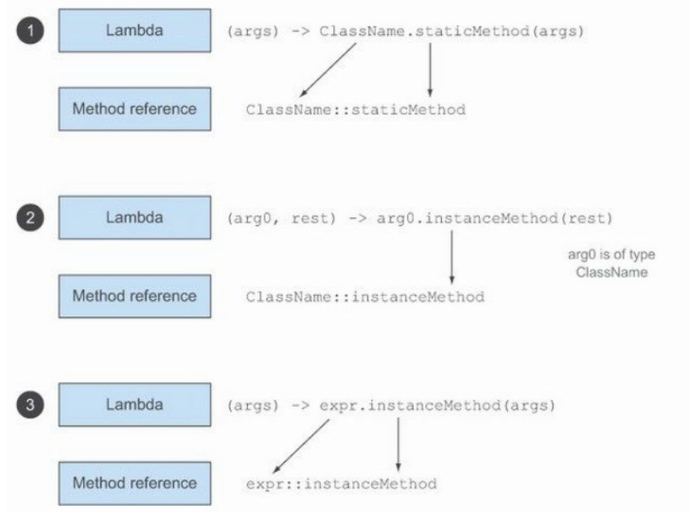

**Putting lambdas and method references into practice!**

To wrap up this chapter and all we’ve discussed on lambdas, we continue with our initial problem of sorting a list of Apples with different ordering strategies and show how you can progressively evolve a naïve solution into a concise solution, using all the concepts and features explained so far in the book: behavior parameterization, anonymous classes, lambda expressions, and method references. The final solution we work toward is this:

inventory.sort(comparing(Apple::getWeight));

**Step 1: Pass code**

public class AppleComparator implements Comparator<Apple> {

public int compare(Apple a1, Apple a2){

return a1.getWeight().compareTo(a2.getWeight());

}

}

inventory.sort(new AppleComparator());

**Step 2: Use an anonymous class**

inventory.sort(new Comparator<Apple>() {

public int compare(Apple a1, Apple a2){

return a1.getWeight().compareTo(a2.getWeight());

}

});

**Step 3: Use lambda expressions**

inventory.sort((Apple a1, Apple a2) -> a1.getWeight().compareTo(a2.getWeight()));

//inventory.sort((a1, a2) -> a1.getWeight().compareTo(a2.getWeight()));

Can you make your code even more readable? Comparator has a static helper method called comparing that takes a Function extracting a Comparable key and produces a Comparator object

**Step 4: Use method references**

We explained that method references are syntactic sugar for lambda expressions that forwards their arguments. You can use a method reference to make your code slightly less verbose (assuming a static import of java.util.Comparator.comparing):

inventory.sort(comparing(Apple::getWeight));

public class Song {

private final String title;

private final String artist;

private final String genre;

private final int year;

private final int timesPlayed;

public Song(String title, String artist, String genre, int year, int timesPlayed) {

this.title = title;

this.artist = artist;

this.genre = genre;

this.year = year;

this.timesPlayed = timesPlayed;

}

//getter & setter

@Override

public String toString() {

return title + ", "

+ artist + ", "

+ genre + ", "

+ year + ", "

+ timesPlayed + "\n";

}

}

public class Songs {

public List<Song> getSongs() {

return new ArrayList() {{

add(new Song("$10", "Hitchhiker", "Electronic", 2016, 183));

add(new Song("Havana", "Camila Cabello", "R&B", 2017, 324));

add(new Song("Cassidy", "Grateful Dead", "Rock", 1972, 123));

add(new Song("50 ways", "Paul Simon", "Soft Rock", 1975, 199));

add(new Song("Hurt", "Nine Inch Nails", "Industrial Rock", 1995, 257));

add(new Song("Silence", "Delerium", "Electronic", 1999, 134));

add(new Song("Hurt", "Johnny Cash", "Soft Rock", 2002, 392));

add(new Song("Watercolour", "Pendulum", "Electronic", 2010, 155));

add(new Song("The Outsider", "A Perfect Circle", "Alternative Rock", 2004, 312));

add(new Song("With a Little Help from My Friends", "The Beatles", "Rock", 1967, 168));

add(new Song("Come Together", "The Beatles", "Blues rock", 1968, 173));

add(new Song("Come Together", "Ike & Tina Turner", "Rock", 1970, 165));

add(new Song("With a Little Help from My Friends", "Joe Cocker", "Rock", 1968, 46));

add(new Song("Immigrant Song", "Karen O", "Industrial Rock", 2011, 12));

add(new Song("Breathe", "The Prodigy", "Electronic", 1996, 337));

add(new Song("What's Going On", "Gaye", "R&B", 1971, 420));

add(new Song("Hallucinate", "Dua Lipa", "Pop", 2020, 75));

add(new Song("Walk Me Home", "P!nk", "Pop", 2019, 459));

add(new Song("I am not a woman, I'm a god", "Halsey", "Alternative Rock", 2021, 384));

add(new Song("Pasos de cero", "Pablo Alborán", "Latin", 2014, 117));

add(new Song("Smooth", "Santana", "Latin", 1999, 244));

add(new Song("Immigrant song", "Led Zeppelin", "Rock", 1970, 484));

}};

}

}

**Lou’s Challenge #1: Find all the “rock” songs**

Lou’s noticed that the diner’s clientele seem to prefer variations on rock music, and he wants to see a list of all the songs that fall under some genre of “rock.”

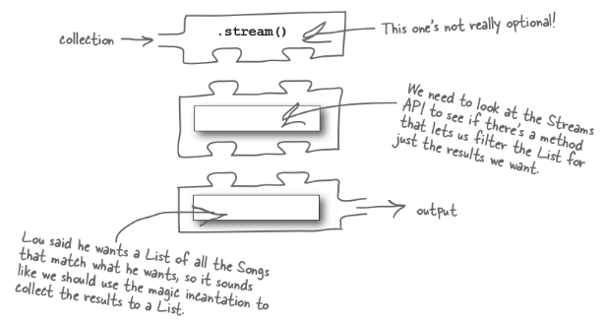

Fortunately, there are hints about how to create a Streams API call based on the requirements Lou gave us: he wants to filter for just the Songs with a particular genre, and he wants to collect them into a new List.

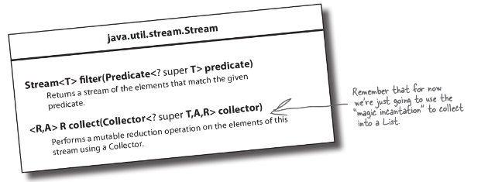

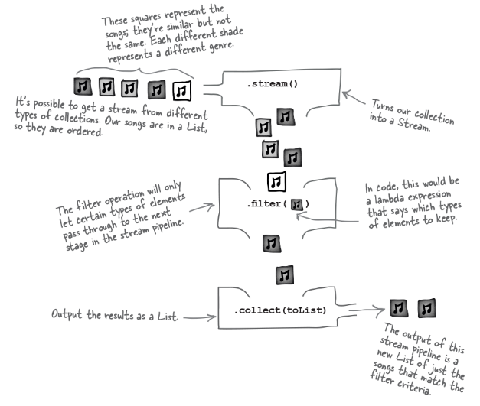

The filter method takes a **Predicate**.

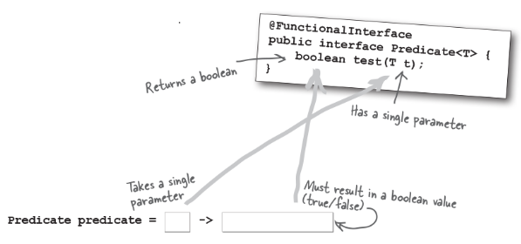

We’ll know what the type of the single parameter is when we plug it into the Stream operation, since the input type to the lambda will be determined by the types in the stream.

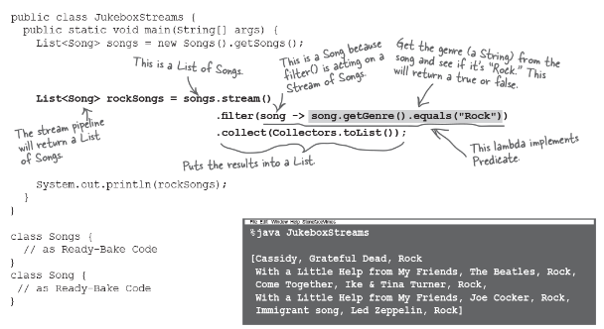

**Lou’s Challenge #2: List all the genres**

Lou now senses that the genres of music that the diners are listening to are more complicated than he thought. He wants a list of all the genres of the songs that have been played.

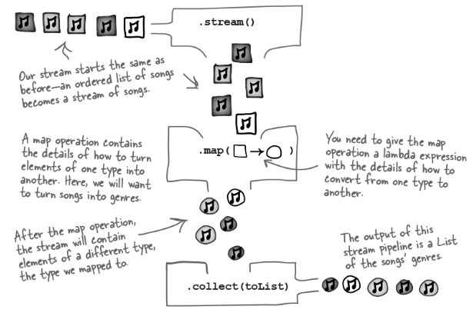

**Mapping from one type to another**

The map method takes a **Function**. The generics by definition are a bit vague, which makes it a little tricky to understand, but Functions do one thing: they take something of one type and return something of a different type. Exactly what’s needed for mapping varies from one type to another.

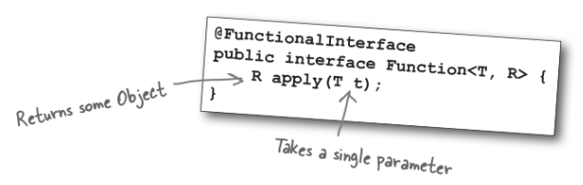

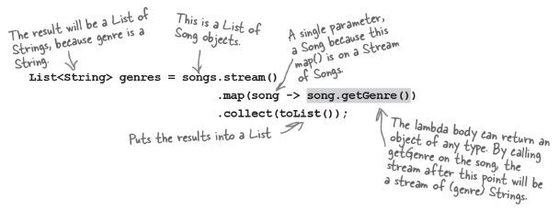



**Removing duplicates**

